Final Report
Level 4
Automated Detection and Trend Analysis of Hate Speech in Sinhala Language
by Team Telos

Faculty of Information Technology
University of Moratuwa
2026

Final Report
Level 4
Automated Detection and Trend Analysis of Hate Speech in Sinhala Language
by Team Telos
Group Members
Index Number | Name | Signature
214053H | Dilhan G.K. | …………………
214022M | Ashen E.D.D. | …………………
214040P | Wijesekara D.T.A | …………………

Supervisor’s Name | Signature
Prof. (Ms.) S. Ahangama | …………………

Faculty of Information Technology
University of Moratuwa
2026

Dedication
This work is dedicated to every Sri Lankan who has been targeted, diminished or endangered by hateful speech online, and to the moderators, journalists and researchers who work to make the country’s digital public square a safer place to speak.
It is dedicated also to the Sinhala language itself, a language spoken by more than seventeen million people yet served by a fraction of the computational resources afforded to the languages of the global north. If this project contributes even a small amount to closing that gap, it will have served its purpose.
Finally, we dedicate this report to our families, whose patience across a long year of late nights made it possible.

Acknowledgement
We wish to express our sincere gratitude to our supervisor, Prof. (Ms.) S. Ahangama, of the Faculty of Information Technology, University of Moratuwa, for her guidance, her patience with our many revisions, and above all for insisting that every claim we made be supported by evidence rather than assertion. The methodological rigour of this project, the significance of testing, the ablation studies, the honest reporting of negative results is a direct consequence of that insistence.
We thank the academic staff of the Faculty of Information Technology for the foundation in machine learning, software engineering and research methodology upon which this work rests, and the non-academic staff for their assistance throughout the year.
We gratefully acknowledge the authors of the Sinhala Offensive Language Dataset, whose decision to release a large annotated Sinhala corpus made the trend-analysis component of this project possible. Low-resource language research advances only when researchers share data, and we have benefited directly from that generosity.
Finally, we thank our families and friends for their unwavering encouragement.

Abstract
The increasing use of social media in Sri Lanka has intensified the spread of hateful and discriminatory content, creating significant challenges for automated content moderation in Sinhala. These challenges are amplified by the language's morphological complexity, limited computational resources, and the widespread use of Romanized Sinhala mixed with English words in online communication. This study presents an integrated research project comprising three complementary modules for the automated analysis of Sinhala hate speech.
The first module addresses text normalization by introducing a confidence-guided transliteration framework that classifies Romanized tokens to determine whether they should be converted to Sinhala Unicode, contextually verified, or preserved as genuine English words. It also identifies unresolved tokens and generates candidate dictionary entries for human validation without modifying the production lexicon automatically. The second module performs hate speech detection using a fusion architecture that combines local, sequential, and contextual language representations. Four fusion strategies were systematically evaluated, with the best-performing model achieving a macro-F1 score of 0.903 on a held-out test set and 0.897 under five-fold cross-validation. Statistical significance testing confirmed consistent improvements over individual models, while confidence estimates and word-level explanations enhanced prediction of transparency. The third module investigates the temporal behavior of hateful discourse by analyzing long-term trends, detecting anomalous periods, evaluating forecasting models, and examining semantic drifts. Results indicate that hate speech volume varies significantly over time despite relatively stable semantic characteristics, while keyword analysis captures event-driven shifts in targeted groups.
Together, these modules provide a reproducible and explainable framework for Sinhala hate speech analysis, supporting robust text normalization, accurate detection, and longitudinal monitoring through an integrated interactive system.
Keywords: Sinhala, hate speech, code-mixing, transliteration, explainable artificial intelligence, model fusion, trend analysis, forecasting.

Table of Contents

List of Figures

List of Tables

Chapter 1 – Introduction

1.1 Introduction
This chapter introduces the research problem addressed by this project; The automated detection and longitudinal analysis of hate speech in Sinhala-language social media content. It sets out the background and motivation for the work with reference to the published literature, states the problem in brief, and defines the aim and objectives of the project. It then describes the proposed solution in terms of its users, inputs, outputs, process, technology, features and system requirements, delimits the scope of what has and has not been attempted, and closes with a description of how the remainder of the report is organized.

1.2 Background and Motivation
Social media has become the dominant medium of public discourse in Sri Lanka. Platforms such as Facebook, X, TikTok, and WhatsApp now carry a substantial fraction of the country’s political argument, community organization, and everyday conversation. This has democratized expression in ways that would have been impossible a generation ago. It has also created an efficient vector for hateful, abusive, and discriminatory content directed at individuals and at ethnic, religious, and political communities. In Sri Lanka this is not a hypothetical harm. Surges of online communal hostility have on several occasions preceded and accompanied real-world violence, and the interval between a hateful post gaining traction and a platform removing it is frequently measured in days rather than minutes.
The obvious response, automated moderation is considerably harder for Sinhala than for the high-resource languages for which commercial moderation tooling was built. Three properties of the problem combine to make it difficult.
First, Sinhala is a low-resource language. Annotated corpora are scarce, pretrained models that represent Sinhala well are few, and the linguistic tooling that practitioners in English take for granted - reliable tokenizers, morphological analyzers, sentiment lexicons - is either absent or immature [12]. Multilingual pretrained models such as XLM-RoBERTa [5] do cover Sinhala, but the quantity of Sinhala text in their pretraining corpora is a small fraction of what is available for English, and downstream performance reflects that asymmetry.
Second, Sinhala is morphologically rich. It is an agglutinative Indo-Aryan language in which a single root may surface in a large number of inflected forms through verb conjugation and nominal case marking. A moderation system built around a fixed vocabulary of offensive terms will therefore miss the majority of the inflected variants of those terms, and informal social media spelling, which is inconsistent even among the same author’s posts, compounds the problem further.
Third - and this is the property that most directly shapes the present project - a large proportion of Sinhala social media text is not written in the Sinhala script at all. It is written in a Romanized, phonetic register colloquially known as Singlish, in which Sinhala words are spelled using Latin characters and interleaved with genuine English words, emoji, numerals and slang. This register is not a degraded form of either language. It is a stable, productive sociolinguistic phenomenon reflecting the bilingual identity of educated Sri Lankan youth, who switch between Sinhala phonology and English vocabulary within a single utterance. A characteristic example is the sentence “Ada mama university yanawa”, which mixes the Romanized Sinhala words for today, I and going with the English word university.
This third property creates a normalization problem that must be solved before any classifier can be applied. Pretrained language models process Sinhala from its Unicode block but were never exposed to Romanized Sinhala during pretraining; to such a model, a Romanized Sinhala token is an arbitrary English-like character sequence that yields a degenerate embedding carrying almost no semantic signal. Converting Romanized Sinhala into Sinhala script is therefore a prerequisite for downstream analysis. However, the existing approaches to normalization of code-mixed South Asian text suffer from a systematic and damaging error: they transliterate every Romanized token indiscriminately, regardless of whether it is genuinely a Sinhala word or an English borrowing. Applied to the example above, such a system converts university into a Sinhala approximation that neither a Sinhala-aware model nor a Sinhala dictionary recognizes as a meaningful morpheme. The result is arguably worse than leaving the text unnormalized, because semantically informative English words have been destroyed.
Beyond normalization and detection lies a third question that the literature has barely touched for Sinhala. Knowing whether an individual post is hateful is useful to a moderator acting on that post. It tells a policymaker, a platform-safety team or a researcher very little about whether hateful discourse is rising or falling, what it is about, whose communities it is targeting, or what is likely to happen next. Answering those questions requires treating the labelled stream as a time series rather than as a bag of independent classification instances. Prior Sinhala work in this direction [23] is descriptive: it reports when hate trended and what topics accompanied it, but it does not forecast future prevalence, does not test whether the meaning of hate changes over time, and relies on a single fragile anomaly statistic.
Two further findings from the literature motivate the specific technical direction this project takes. Deep learning methods substantially outperform classical machine learning for hate speech detection, including for Sinhala [8], [22]. And combining multiple models through fusion improves accuracy over any single constituent model [9], [27]. These two insights have not previously been unified for Sinhala in a manner that is simultaneously systematic, explainable and statistically validated. That gap, together with the social importance of the problem, motivates the present work.

1.3 Problem in Brief
The project addresses three related research problems, one per module.
The normalization problem is, Given a stream of Sinhala-English code-mixed social media text in which Sinhala words appear in Romanized Latin script alongside genuine English words, correctly identify which tokens require conversion to Sinhala script, assign a calibrated confidence score to each such identification, perform conversion selectively only on tokens identified as Sinhala with sufficient confidence, and route uncertain tokens to a verification stage rather than applying automatic transliteration. The system must also identify unknown tokens for dictionary enrichment while accommodating the continuous evolution of social media language, including new romanization conventions, slang, abbreviations, and borrowed words, all without permanently altering the production dictionary through any unsupervised process.
The detection problem. Given a Sinhala comment written in Sinhala script, classify it as hateful or not hateful on the basis of its meaning and context rather than the presence of individual keywords; do so more accurately than any single model can, with the improvement demonstrated statistically rather than merely asserted; and accompany every decision with a human-understandable explanation suitable for a moderation workflow.
The trend analysis problem. Given a labelled, timestamped corpus of Sinhala posts, determine when hateful discourse spikes, what it concerns, what its future prevalence is likely to be, and whether its meaning as distinct from its volume changes over time, with every headline claim supported by an appropriate significance test.

1.4 Aim and Objectives

1.4.1 Aim
To design, implement and evaluate an automated system for the detection and longitudinal analysis of hate speech in Sinhala-language social media text, comprising a confidence-based input normalization module, an explainable hybrid-fusion detection module that statistically significantly outperforms strong single-model baselines, and an independent trend-analysis module that forecasts and characterizes hateful discourse over time.

1.4.2 Objectives
- To design and implement a token-level confidence classification system that assigns each token in a code-mixed sentence a probability distribution over the labels Singlish, English and Unknown, and to enforce a threshold-based policy mapping that distribution to one of three actions: transliterate, verify, or preserve.
- To develop a Sinhala phonetic transducer implementing a greedy longest-match algorithm for converting Romanized Sinhala to Sinhala script, integrated with dictionary and variant lookup in a hybrid fallback cascade.
- To design and implement an adaptive lexicon expansion component that discovers, ranks and queues novel tokens for human review without modifying the production dictionary automatically.
- To build lexical deep models based on convolutional and recurrent architectures over sub-word embeddings, and a contextual model based on a fine-tuned multilingual transformer.
- To design and systematically compare four fusion strategies and identify the most effective, Also prove statistically that the best fusion outperforms both the best single model and the strongest classical baseline, using cross-validated significance testing.
- To provide word-level explainability (XAI) for every prediction.
- To construct a longitudinal analysis pipeline producing time-series decomposition, consensus-based spike detection, a rigorous forecasting benchmark, topic models and a context-drift analysis, each validated by an appropriate statistical test.
- To deliver interactive user interfaces supporting normalisation, live prediction, explanation and longitudinal exploration.
Each objective is evaluated individually in Chapter 8.

1.5 Proposed Solution
The users of the system are content moderators, platform-safety analysts and researchers studying online discourse in Sri Lanka. A moderator uses the system to triage a queue of reported comments and to justify the resulting decisions; a researcher uses it to characterize how hateful discourse has behaved across an extended period.
The input to the normalization module is raw social media text in any of the forms that occur in practice: native Sinhala script, Romanized Singlish, Sinhala-English code-mixed text, or a mixture of all three within a single comment. Its output is clean, canonically normalized Sinhala script text in which genuine English words have been deliberately preserved. The input to the detection module is a Sinhala comment, which may be the output of the normalization module, passed across by the user through the interface and its output is a hateful or not-hateful label, a confidence value, a per-branch breakdown, and a word-level explanation. The input to the trend-analysis module is a labelled corpus carrying timestamps, and its outputs are decomposed time series, detected anomalous periods, forecasts with quantified uncertainty, topic models, and drift analyses.
The process is described in full in Chapter 4. In outline, the normalization module cleans and tokenizes the text, identifies the language of each token, computes a calibrated confidence score, routes each token to one of three actions on that basis, and converts only those tokens routed for conversion. The detection module preprocesses the comment, computes three architecturally distinct representations of it, fuses them through a learned or optimized combination layer, emits a decision, and explains that decision. The trend-analysis module decomposes the labelled stream into temporal bins, analyses those bins along both a volume axis and a meaning axis, and exposes the results through a dashboard.
The technology adapted is described and justified in Chapter 3. It includes XLM-RoBERTa [5] as a multilingual contextual encoder, FastText sub-word embeddings [3], convolutional [16] and recurrent [13] architectures, the Grey Wolf Optimizer [21] and Bayesian optimization [1] for weight and hyperparameter selection, LIME [26] and SHAP [20] for explanation, and a combination of classical time-series methods and neural sequence models for the longitudinal analysis.
The distinctive features of the solution are the per-token decision about whether to transliterate rather than merely how; the human-in-the-loop lexicon expansion loop that never mutates the production dictionary automatically; the systematic comparison of four fusion strategies with no hand-set combination weights; the integrated explainability layer; and the statistically validated forecasting benchmark and meaning-drift analysis for a language in which neither has previously been attempted.
System requirements for inference are modest. The normalization module operates in a rule-based mode requiring no model download and no graphics processor, and the detection module performs inference on a standard processor using cached branch outputs. Training the deep models benefits substantially from a graphics processor and was performed on cloud-hosted hardware.

1.6 Scope and Delimitations
The following are within scope. Sinhala-English code-mixed text drawn from social media platforms such as Facebook, X, TikTok, and WhatsApp; token-level language identification in the Romanized Sinhala (Singlish) register; confidence estimation, selective conversion between Romanized and Sinhala script, and routing of uncertain tokens to a verification stage; preservation of genuine English borrowings and code-switched English words without transliteration; identification of previously unseen tokens for lexicon enrichment; binary hate versus not-hate classification of Sinhala comments; word-level explanation of classification decisions; and longitudinal analysis of a labelled temporal corpus including decomposition, anomaly detection, forecasting, topic modelling and drift testing.
The following are outside scope and are discussed as further work in Chapter 7. Tamil and other Sri Lankan language processing; multi-class categorization of hate by type or severity; translation between Sinhala and English; full morphological analysis of Sinhala script text; automatic correction of spelling errors in English tokens; real-time deployment at platform scale; and the automatic execution of the trend-analysis module on the output of the detection module, which is treated throughout as a future integration rather than a current capability.

1.7 Structure of the Report
The remainder of this report is organized as follows. Chapter 2 surveys the published literature across code-mixing and Romanized text, token-level language identification, machine transliteration, hate speech detection, model fusion, explainable artificial intelligence and temporal analysis of online discourse, and concludes by identifying the specific research gaps this project addresses. Chapter 3 describes the technologies adapted to address those gaps and justifies why each is appropriate to the Sinhala problem. Chapter 4 presents the proposed approach, including the overall project architecture and the relationship between the three modules. Chapter 5 gives the analysis and design, including the top-level system architecture, the requirements, the design of each module and the interface contract between the first two. Chapter 6 describes the implementation of each module identified in the design. Chapter 7 reports and discusses the evaluation, compares the solution with prior work, and states the limitations and further work. The list of references and four appendices follow.

1.8 Summary
This chapter introduced the problem of automated detection and trend analysis of Sinhala hate speech, established its social importance and technical difficulty with reference to the literature, and stated the aim, objectives, proposed solution and scope of the project. Three distinct research problems were identified, corresponding to the three modules of the delivered system. The next chapter reviews existing approaches to these problems and identifies the specific gaps that this research addresses.

Chapter 2 – LITERATURE REVIEW

2.1 Introduction
The three research problems that this project seeks to solve, and the proposed solution, were presented in the previous chapter. This chapter briefly reviews the literature available on those problems. It explores code-mixing and Romanized text in SA languages, token-level language identification, machine transliteration, confidence estimation and calibration, model fusion and ensemble, Sinhala work, explainable AI for text, and the temporal analysis of online discourse. This chapter ends with a comparison of the capabilities that have been targeted in this work to those of previous systems and a statement of the research gaps.

2.2 Code-Mixing and Romanized Text in South Asian Languages
It is a common phenomenon in multilingual communities for people to mix two or more languages in a single speech. The computational treatment of code-mixed text has been explored with various language pairs and the widely adopted framing views the problem as a sequence labelling problem over token-level language markers. Systems for language pairs like Spanish-English work on languages that share the same script, but are lexically different. The Sinhala case adds another greater complexity: Romanized Sinhala is indistinguishable from English, so there is no visual indication of the language of a token.
Three-way mixing experiments have demonstrated that the character n-gram features that are good for distinguishing between two languages fail in three-language settings where sequences of characters are shared by all three languages. That discovery makes it desirable to include phonological and morphological heuristics in addition to distributional features, a design principle that is directly implemented in the lexical feature extractor of the present system. Morphologically rich code mixed pairs have also been studied, and it has been demonstrated that language identification accuracy can be significantly boosted by separating the suffixes of one language from the stems of another language by employing morphological segmentation. Relevance to Sinhala is explicit; Romanized Sinhala verbs have distinct suffixes marking present tense, anterior aspect and interrogative mood, which are characteristic of the verb system in Sinhala.
Shared-task evaluations on sentiment analysis of code-mixed social media text have put several points to this project: Normalization quality is directly correlated with downstream task accuracy: Teams that worked on careful pre-normalization outperformed teams that pre-normalized using models on code-mixed social media text by a few points. This offers empirical evidence for the importance of normalization as a first-class research problem and not just a preprocessing step.
Studies of the Sri Lankan context of social media have revealed three types of romanization that are common: phonological, in which the words are spelled in a manner that is close to how they are pronounced, according to the rules used in English orthography; rhyme-based, which attempts to preserve the word endings, while varying the vowel representation; and a more systematic transliteration by characters. There is no single convention which prevails, and each author alternates among the conventions. All three are therefore to be accommodated by any transducer to be used for this register.

2.3 Token-Level Language Identification
For languages that have different writing systems, the task of language identification at the document level is well solved. The problem that is dealt with here is quite different: Identification at the level of the individual token in a Romanized code-mixed context where both candidate languages are written in the Latin script.
Weakly supervised word level identification has been shown to work well with small seed lexicons and character n-gram models [17] that show good generalization without the need of large labelled corpora. The model is easily applicable to the Singlish case, where there is little labelled data, but there are patterns at the character level, especially at the consonant level, that allow one to identify Romanized Sinhala from English with acceptable accuracy. Later work confirmed that hybrid character-word models are superior to either representation for code-switched identification [15] or that the most common errors that occur in the residual errors are English technical borrowings taken up into the code-mixed register. This error category is exactly the one which inspires the intermediate verification class in this design.
Context has also been demonstrated to be important. The character-level language models with code-mixed data also boost the identification performance with a small but consistent margin, and the context window of two tokens on either side of the target token further improves the identification performance when it is ambiguous. The current system has just such a context-window boost.

2.4 Machine Transliteration
There is significant literature on machine transliteration (text-to-text conversion of the text while retaining the phonological content). The formalization of transliteration in the form of a sequence of weighted finite-state transductions [18] provided the foundation for the transliteration phonetic transducer used here. The mapping of the source word to the source phoneme sequence, followed by the target phoneme sequence and finally the target word is a natural fit for the Singlish case in that the source word is mapped to the Romanized characters which are then mapped to the phoneme sequence which is then mapped to the Sinhala glyphs, all within the abugida structure of the writing system.
The main problem that is surveyed across the Arabic, Chinese, Japanese and various Indian scripts is the ambiguity of character mappings: a single Romanized character sequence can map to several valid target character sequences based on phonological context. The Sinhala-specific one relates to the treatment accorded the vowel that follows a consonant, which can be the vowel that is inherent with every consonant character in an abugida or an additional vowel sign (depending on the position and the preceding consonant character). The present system overcomes this by explicit handling of viramas in the greedy longest-match transducer.
Sequential-to-sequential models of the neural network perform well on known words but poorly on novel morphological forms. Research on Romanized Arabic has shown that hybrid models that use a character-level model and dictionary lookup achieve a much higher accuracy than purely neural models on out-of-vocabulary tokens. It is that principle that is being used in the hybrid cascade used here: dictionary lookup, variant lookup, phonetic transduction, and a preserve fallback.
Early rule-based transliteration in the Sinhala script was based on a manually developed phoneme inventory [12] and was successful at transliterating dictionary words, but not morphologically complex words. This is expanded upon in the present work, which incorporates a greedy longest-match algorithm that is more robust to consonant clusters, virama insertion and word-final consonants.

2.5 Confidence Estimation and Calibration
The normalization module's decision architecture is based on the literature related to probabilistic classification and selective prediction. It has been demonstrated that modern neural networks are systematically overconfident: their prediction probabilities are not consistent with their empirical accuracy, especially high prediction probabilities [11]. The objective of the evaluation framework is to use the Expected Calibration Error (ECE) introduced in this work, which consists of a weighted mean absolute error between confidence and accuracy over the bins.
Selective prediction allows a classifier to abstain when it is uncertain about a given input while maintaining high accuracy on the inputs it predicts.Here we take a three-way decision policy, the middle class being a soft abstention that is followed by contextual resolution and not a call to the human oracle and formalize this policy with selective prediction. Work on out-of-distribution detection has also demonstrated that maximum output probability is not a good metric for in-distribution membership, which is why the current system explicitly models an Unknown class, rather than assuming that a low confidence score means that the class is unfamiliar.

2.6 Sinhala Natural Language Processing
Sinhala Natural Language Processing (NLP) remains a comparatively low-resource research area, with most existing work focusing on native Unicode Sinhala rather than the Romanized Sinhala-English code-mixed register addressed in this research. Previous studies have developed morphological analysers, word embeddings, and corpora for Sinhala, demonstrating the importance of modelling the language's rich morphological structure for downstream NLP tasks. Research on Sinhala social media has further identified multiple Romanization conventions, including phonological Romanization, rhyme-based Romanization, and systematic character-based transliteration. As no single convention dominates social media communication, normalization systems must accommodate these variations while preserving genuine English borrowings and code-switched words. More recent studies on Sinhala-English hate speech detection have also highlighted that Romanized Sinhala tokens are frequently misidentified as English, reducing the effectiveness of downstream language models. These findings collectively motivate the development of a robust normalization stage capable of accurately identifying and selectively transliterating Romanized Sinhala before subsequent hate speech detection and trend analysis.

2.7 Lexicon Expansion and Dictionary Induction
Lexicon expansion has been widely studied as a means of improving language resources for low-resource and morphologically rich languages. Existing work demonstrates that distributional evidence, character-level patterns, and contextual information can be effectively combined to identify previously unseen vocabulary and expand lexical resources with minimal manual effort. Active learning approaches further show that uncertain predictions provide the greatest value for human annotation, allowing dictionary growth to occur while maintaining quality control. These findings support the use of a controlled lexicon expansion strategy in which previously unseen Romanized Sinhala tokens are identified as candidates for review and enrichment, while preventing unsupervised modifications to the production dictionary. Such an approach enables the system to adapt to the continuous emergence of new Romanization conventions, slang, abbreviations, and borrowed words commonly observed in social media.

2.8 Hate Speech Detection - From Classical Learning to Transformers
Hate speech is defined as language which attacks or demeans a group or an individual based on attributes like ethnicity, religion, gender or nationality. It is hard to automatically detect, as hatefulness is context-dependent, can be conveyed implicitly or sarcastically, and changes over time as communities evolve coded vocabulary. In morphologically rich languages with low resource, these challenges are exacerbated by the lack of resources, spelling variation, and the lack of mature tooling for such languages [8], [22].
There are two problems with the definitions that need to be recognized, since they limit what any detection system can justifiably claim. One is that hatefulness is not an attribute of a string per se. The same lexical item can be an unambiguous slur, a reclaimed in-group term, or a neutral quotation in a third situation. Any system that assigns labels to strings, not to utterances-in-context, is thus making an approximation of a target system it cannot see completely, and the ceiling on its accuracy is determined by this approximation, not by the capacity of the system. This is the main reason for considering the contextual branch as essential and not as one of the options in the present work for the treatment of the contextual branch.
The second challenge is the interannotator agreement. There is typically less inter-annotator agreement for corpora of hateful content than for other types of corpora, such as those for topic classification, as there is some normative component to the judgment of what constitutes an attack on a group. The reported accuracy value is thus compared to labels that are also subject to disagreement, and discrepancies between systems on the same corpus can be in the noise of that disagreement. This observation is the reason for the focus on significance testing throughout this present work; an improvement that passed a paired test on several folds is a more material improvement than one that passed a paired test on only one fold.
The early detectors used hand-crafted or term-frequency features and classical classifiers such as support vector machines, logistic regression and tree ensembles. Convolutional networks for sentence classification [16] and LSTM recurrent architectures for sequential context [13] were introduced, adding the power to model local patterns and sequential context, respectively. Deep contextual representations have since established new benchmarks with the transformer architecture [29] and pre-trained language models like BERT [6]. In multilingual and low-resource scenarios, XLM-RoBERTa [5] extended this paradigm by pretraining a single model on one hundred languages, including Sinhala, giving it contextual representations without the need to pretrain language-specific models, as would be required with Sinhala data volumes.
Text representation has evolved parallel to sparse statistical vectors to dense distributed embeddings. The static embeddings are of particular interest here as one of them, FastText [3], encodes words as bags of character n-grams, which gives them robustness against the rich morphology and frequent out-of-vocabulary items found in Sinhala. However, static embeddings cannot disambiguate context, which is addressed by contextual embeddings from transformers and is thus a key element of context-sensitive hate detection.

2.9 Hybrid Model Fusion Approaches
It is a well-known method to improve the accuracy of classifiers to combine them. A direct methodological importance to this project was noted in the work on fusing transformer-based and convolutional classifiers for English: If the classifiers are weak, the fusion does not help; if they are strong, but not diverse, then the fusion does not help; and if they are strong and diverse, then a weak one may actively harm the fused result. The model fusion technique was shown to increase the accuracy on subsequent research on large multi-source English datasets [27].
The most relevant to the present work is a hybrid approach developed for Arabic [9] which uses weights selected by the Grey Wolf Optimizer [21] for the fusion of the outputs of the three classifiers, namely convolutional, recurrent, and dense classifiers. This is the most similar methodological model to the detection module described here. It does not attack Sinhala; it is a comparison of only one fusion mechanism and not several, and it doesn't explain its decisions.

2.10 Hate Speech Detection for Sinhala
For Sinhala specifically the literature is small. Classical and deep classifiers have been applied to Sinhala hate speech [8], but that study restricted itself to single models, without fusion and without explainability. A deep-learning ensemble for Sinhala posts [22] demonstrated that ensembling outperforms traditional machine learning and generalizes to unseen data; however, that ensemble is homogeneous, averaging architecturally similar models, and it neither compares fusion strategies nor combines lexical and contextual views, nor does it explain its decisions.
Work on Sinhala-English code-mixed hate speech using a fine-tuned transformer [28] is directly relevant to the motivation for the normalization module. That study reported that its primary failure mode was the misclassification of Romanized Sinhala tokens as English, leading to incorrect polarity assignment. This is precisely the failure that selective, confidence-based normalization is designed to prevent.
The release of the Sinhala Offensive Language Dataset [24], the first large annotated Sinhala offensive-language corpus, materially changed what is feasible in this area and provides the data source for the trend-analysis module of this project.

2.11 Explainable Artificial Intelligence for Text

Explainability is becoming a necessity and not an option, as machine learning models are increasingly being used in decisions that have consequences. A moderation of decision is a decision that removes a person's speech, which is a consequence by any reasonable standard, and one that cannot be explained by the system cannot be audited, appealed or improved.

Two properties of an explanation that are often confused are: first, that it is explanatory; and second, that it is measurable. Two properties of an explanation that are often confused are that it is explanatory and that it is measurable, and only the latter is directly measurable. The degree to which an explanation reflects the computation that the model actually made is faithful, and the degree to which a human finds the explanation convincing is plausibility. These come apart; An explanation can be very plausible and completely unfaithful, more dangerous failure mode because it creates confidence without giving it. The present work tackles this by creating two different methods of attributions based on distinct theoretical foundations, local surrogate fitting and cooperative-game attribution and considering the consensus between the two as an indication of faithfulness which neither method on its own can give.

The second practical factor that is often ignored is the unit of attribution. An explanation is only of use to a moderator if the units in the explanation are ones that the moderator recognizes. This is not automatic for a language that is written in an abugida like Sinhala, a tokenizer that splits at combining marks would generate attributions over fragments that are not words and are not meaningful to a Sinhala reader. This consideration is closely related to the design decision, that whitespace should be used for tokenization purposes for the purpose of explanation.

LIME [26] provides an explanation for an individual prediction by adding noise to the input and finding a locally faithful linear approximation, which results in per-word importance weights. SHAP [20] is a game-theoretically-based approach to explain a prediction to its input features. Both are model agnostic, which is crucial in this context as the deployed model is a combination of three heterogeneous networks, and the internal weights of each of the networks cannot be examined to explain the model. To the best of our knowledge, explainability for Sinhala Hate Speech detection has not been reported before.

2.12 Temporal and Trend Analysis of Online Discourse
The methods adapted by the trend-analysis module are individually mature. Seasonal-trend decomposition based on locally weighted regression [4] separates a series into trend, seasonal and residual components. Isolation Forest [19] provides multivariate anomaly detection by measuring how readily a point is isolated in feature space. Recurrent networks [13] serve both as forecasters and, in autoencoder configuration, as reconstruction-error anomaly detectors. Hybrid forecasting combining a linear autoregressive model with a neural model of its residuals [30] is a widely adopted template. Scale-free forecast error measurement [14] permits comparison across series of differing magnitude, and formal testing of predictive accuracy [7] establishes whether an observed difference between two forecasters is real or attributable to chance.
For topic modelling, latent Dirichlet allocation [2] remains the classical baseline, while BERTopic [10] clusters transformer embeddings to produce topics that are frequently more interpretable on short, noisy text. Sentence-level embeddings [25] provide the representation in which the meaning of a corpus slice can be compared against another slice, which is the basis of the drift analysis undertaken here.
The directly comparable Sinhala work [23] applies a time-series approach to Sinhala hate speech, identifying trending periods and topics. It is descriptive rather than predictive: it does not forecast future prevalence with a benchmarked model, does not test whether the meaning of hate drifts, and does not fuse multiple anomaly detectors by consensus. The trend-analysis module of this project occupies precisely that gap and builds directly on that time-series foundation.

2.13 Comparative Analysis
Table 2.1 compares prior systems relevant to the normalisation problem across the design dimensions that matter for code-mixed Sinhala. Table 2.2 performs the equivalent comparison for the detection problem, and Table 2.3 for the trend-analysis problem. Together they make the research opportunity explicit.
Table 2.1: Comparison of prior normalization and transliteration approaches
System | Language pair | Selective transliteration | Calibrated confidence | Lexicon expansion
King and Abney [17] | Various | No | No | No
Knight and Graehl [18] | Various | No | No | No
Jaech et al. [15] | Arabizi–English | Partial | No | No
Hettige and Karunananda [12] | Sinhala–English | No | No | No
Uyangoda et al. [28] | Sinhala–English | No | No | No
Module 01 of this project | Sinhala–English | Yes (three-class) | Yes | Yes (human-in-the-loop)
Table 2.2: Comparison of prior hate-speech detection approaches
Work | Language | Fusion strategies compared | Lexical + contextual | Optimised weights | Explainability | Statistical proof
Fernando et al. [8] | Sinhala | None | No | No | No | No
Munasinghe and Thayasivam [22] | Sinhala | Homogeneous only | No | No | No | No
Sharif et al. [27] | English | Model fusion | No | No | No | Partial
Gasmi et al. [9] | Arabic | Weighted only | Yes | Yes | No | Partial
Module 02 of this project | Sinhala | Yes (four) | Yes | Yes | Yes | Yes
Table 2.3: Comparison of prior temporal analysis approaches for Sinhala
Work | Descriptive trends | Consensus anomaly detection | Benchmarked forecasting | Meaning-drift testing
Rajapaksha et al. [23] | Yes | No | No | No
Ranasinghe et al. [24] | Corpus only | No | No | No
Module 03 of this project | Yes | Yes (six detectors) | Yes (with significance test) | Yes (three measures)

2.14 Research Gaps
The survey reveals eight gaps, which the present project addresses. They are grouped by modules.

2.14.1 Gaps in Input Normalization
- Indiscriminate against transliteration. Current systems for South Asian code-mixed text have assumed that Romanized text is monolingual and applied the conversion in a uniform manner to all Romanized tokens, causing the corruption of the original English words.
- Unsafe lexicon growth. As the vocabulary of social media changes, dictionary coverage needs to increase, but there is no existing system that offers an expansion pipeline with a review gate that can structurally prevent the unsupervised mutation of the production dictionary.

2.14.2 Gaps in Hate Speech Detection
- Prior Sinhala hate-speech detection studies rely on individual models or homogeneous ensembles, and do not exploit heterogeneous fusion that combines lexical and contextual representations for final prediction.
- Prior Sinhala hate-speech detection models operate as black-box classifiers, providing prediction labels without interpretable explanations, which limits transparency, trust, and practical adoption in real-world content moderation.

2.14.3 Gaps in Trend Analysis
- Prior Sinhala trend work is descriptive rather than predictive; it characterises the past but never forecasts future prevalence against a benchmark.
- Prior work measures the volume of hate but never tests whether its meaning changes over time, and relies on a single fragile anomaly statistic rather than a consensus of detectors.

2.15 Summary
This chapter surveyed the literature relevant to the three research problems of this project and identified specific gaps that motivate the work. For normalization, prior systems transliterate indiscriminately, provide no calibrated per-token confidence, and offer no safe mechanism for lexicon growth. For detection, no prior Sinhala work compares fusion strategies, fuses heterogeneous lexical and contextual views, or explains its decisions. For trend analysis, prior Sinhala work is descriptive rather than predictive and does not test whether the meaning of hateful discourse evolves. The next chapter describes the technologies adapted to address these gaps and justifies why each is appropriate to the Sinhala problem.

Chapter 3 – TECHNOLOGY ADAPTED

3.1 Introduction
The technologies adapted to solve them are described in this chapter. For each technology, the chapter states what it is, what role it plays in the solution, and most importantly why it is appropriate to the specific difficulties of Sinhala identified in Chapter 2. The point is not to simply list technologies in the abstract, but to explain the rationale behind each selection based on the problem. Also noted in the chapter are the alternatives that were considered but not adopted, as a defensible design is defined as one that excludes as well as includes.

3.2 Text Representation Technologies

3.2.1 Term Frequency–Inverse Document Frequency Representations
The classical baselines used for measuring the deep models are represented by word and character n-grams using term frequency-inverse document frequency (TF-IDF). The character n-gram element is not a random feature. The language is morphologically rich and a word-only representation assumes that all of the inflected forms of a root are of a different type, which breaks up the statistical evidence for that root. The sub-word regularities captured by character n-grams are general across inflected forms, as shown in the ablation study reported in Chapter 7, which demonstrates that they are the predominant lexical representation in this corpus.

3.2.2 FastText Sub-word Embeddings
In the case of FastText [3], each word is represented as a bag of character n-grams and the word representation is obtained by summing the vectors of the n-grams. This type of construction is ideally suited to Sinhala in two ways. First, it produces sensible vectors for morphologically inflected forms, even if the exact forms were not very common in the training corpus, because the constituent n-grams are common to more frequent relatives. Second, it generates a usable vector for a word that has not been seen before, which is important for a language that has limited corpora and whose social media register produces new forms constantly. Here, the Sinhala vectors were pre-trained to be three hundred dimensional.

3.2.3 XLM-RoBERTa as a Contextual Encoder
XLM-RoBERTa is a multilingual masked language model trained on a large-scale dataset of filtered web-crawl text in one hundred languages with a well-optimized training objective[5]. It is based on the transformer architecture with twelve encoder layers, seven hundred and sixty-eight hidden units and twelve self-attention heads, resulting in approximately one hundred and twenty-five million parameters for the base model used in this work [29].
It is chosen because of three reasons. It is semantically meaningful rather than arbitrary and represents Sinhala; The pretraining corpus is a relatively small, but not trivial, amount of Sinhala script text from encyclopedic, news and governmental sources. It can be used to encode cross-lingual text, as it has a shared sub-word vocabulary that partially captures the phonological similarity between scripts, making it useful for the normalization module as a context encoder for Romanized Sinhala tokens. It also generalizes unseen tokens. If a word is not in any fine-tuning set, it pretrained embedding will give a much more informative starting point than a random embedding.
In the normalization module, the encoder is used in lazy-loaded mode. It is not created until it is needed, which means that it can be used in a purely rule-based configuration on hardware that has no graphics processor or high-speed network connection an important practical feature for a component to be deployable from day one.

3.3 Deep Learning Architectures
Three architectures are adapted for the detection module. Each captures a different kind of evidence, and the diversity between them is a deliberate design requirement rather than an accident of availability.

3.3.1 Convolutional Networks for Text
A convolutional network for sentence classification uses multiple one-dimensional convolutions of different widths on the embedding sequence and then max-over-time pooling [16]. This identifies the most salient n-gram patterns in the local context regardless of their position within the comment, which is appropriate for the detection of multi-word slurs and fixed abusive constructions that have a local meaning.

3.3.2 Bidirectional Long Short-Term Memory Networks
The long short-term memory architecture solves the vanishing-gradient problem of simple recurrent networks by maintaining a gated cell state, which enable dependencies to be propagated over longer distances [13]. Its bidirectional variant reads the sequence in both directions, and it concatenates the representations that it reads, giving the representation of a position both the left and right context. This encodes word order and sequential dependency that is lost in the convolutional branch.

3.3.3 Fine-tuned Transformer
The third branch is a linear classification head that fine-tunes XLM-RoBERTa. This provides context-specific knowledge that underlies context-sensitive hatefulness, the ability to recognize a word which is used abusively from the same word used innocuously.
These three architectures are intentionally heterodox. As discussed in Chapter 2, fusion is only beneficial when the individual components are strong and make different errors. The precondition is satisfied by the selection of three architecturally different models.

3.4 Fusion and Optimization Technologies
The fusion layer is achieved in three different ways; stacking with a logistic-regression meta-learner, attention-based fusion with a small neural gating network, and weighted combination of branch probabilities.
There are two optimization technologies for weight selection. Optuna [1] is a Bayesian hyperparameter optimization framework based on a tree-structured Parzen estimator that models the distribution of good and bad configurations separately and samples where their ratio is most favourable. The Grey Wolf Optimizer [21] is a nature-inspired metaheuristic which simulates the social hierarchy and surrounding hunting strategy of grey wolves, where three best solutions are known and the population of candidate solutions is guided by these three individuals.
The technologies are not just about performance, but about methodology. One of the key features of this project is that no manual setting of the combination weight is implemented. All fusion weights are learned by back-propagation, fitted as a meta-learner coefficient, or selected by one of these two optimizers with respect to a validation objective. Systematic selection eliminates both the problems of hand-tuned weights and unconscious fitting to the test set.

3.5 Time-Series and Topic Modelling Technologies

3.5.1 Decomposition and Stationarity Testing
Seasonal-trend decomposition using locally weighted regression [4] separates a series into trend, seasonal and residual components without assuming a parametric form for any of them. This is appropriate for a social media signal whose seasonality is real but irregular. Augmented Dickey-Fuller testing establishes whether the series is stationary, which determines whether observed movement represents permanent drift or mean-reverting fluctuation.

3.5.2 Anomaly and Change-Point Detection
Six detectors are run in parallel and fused by consensus. Three are elementary statistical rules operating on standard deviations, interquartile range and a rolling local window. One is a cumulative-sum change-point statistic that accumulates sustained deviation rather than reacting to single excursions. One is Isolation Forest [19], which detects multivariate anomalies by measuring how few random partitions are required to isolate a point. The last is a recurrent autoencoder [13] that flags periods it reconstructs poorly. Using six detectors and requiring agreement addresses gap G8 directly: each individual detector rests on assumptions that are violated somewhere on a bounded, noisy weekly signal, but the assumptions are violated in different places.

3.5.3 Forecasting and Forecast Evaluation
Three forecasters are benchmarked; a recurrent network [13], an autoregressive integrated moving average model, and the hybrid of the two [30] in which the linear model captures the linear structure and a neural model learns its residuals. Two naive baselines persistence and seasonal persistence provide the floor below which no method may claim value. Evaluation uses mean absolute scaled error [14], which is scale-free and directly interpretable, a value below one indicating that a method beats the naive baseline. Whether an observed difference between two forecasters is real is established by a formal test of predictive accuracy [7] rather than by inspection of the error figures.

3.5.4 Topic Modelling and Semantic Representation
Latent Dirichlet allocation [2] provides the classical topic baseline, with the number of topics chosen objectively by a coherence sweep rather than assumed. BERTopic [10] provides the main topic model, clustering transformer embeddings through dimensionality reduction and density-based clustering and then extracting class-based term weights. It is preferred for short noisy social media text, where the bag-of-words assumption underlying the classical model is weakest. Multilingual sentence embeddings [25] provide the representation space in which the meaning of one temporal slice of the corpus can be compared with another, which is the basis of the drift analysis.

3.6 Explainability Technologies
For word-level explanation, LIME [26] and SHAP [20] are used. Neither model is agnostic, but it is a necessity. The model deployed is the result of a fusion of three different networks, and no inspection of any single set of internal weights could explain the fused output. They share the common method of exploring the model's behavior by interacting with its input-output interface, the latter of which is neatly exposed by the fusion as a probability function. If two independent methods are used instead of one, there is a consistency check. When both methods agree on the words that are driving a decision, the confidence in the attribution is significantly increased.

3.7 Statistical Evaluation Technologies
McNemar's test for paired nominal outcomes on a single frozen split, a paired bootstrap over that split, and over five-fold stratified cross-validation, a paired t-test, a Wilcoxon signed rank test and Cohen's d effect size provide rigorous validation. The predictive accuracy test used for the forecasting benchmark is described above and for the drift analysis, the nulls are permutation nulls which are created by shuffling the timestamps over and over again. The reason that such technologies exist in the design is to ensure that the difference between a real improvement and a favorable random split can be demonstrated, not assumed.

3.8 Unicode and the Sinhala Script
The Sinhala script is encoded in the Unicode Standard in a block of eighty code points. The script is an abugida: each consonant character carries an inherent short vowel, which is suppressed by a virama character and replaced by explicit vowel signs for other vowels. This structure is what the phonetic transducer must reproduce, and getting it wrong produces text that is visually plausible but lexically meaningless.
Canonical composition normalization is applied as the first and last processing step. This is critical for Sinhala because certain character sequences have both a precomposed single-code-point form and a decomposed base-plus-combining-mark form. Without normalisation, identical visible glyphs produce different byte sequences, which causes hash collisions in feature extraction and false mismatches in dictionary lookup. The system additionally performs Sinhala-specific sequence validation, detecting and removing orphaned vowel signs and orphaned viramas that appear in improperly composed social media text. A zero-width-joiner-aware tokeniser preserves conjunct characters that would otherwise be fragmented into meaningless pieces.

3.9 Software Stack and Development Tools
The entire system is written in Python. PyTorch provides the deep learning framework, and it was selected because of its define by run execution model, which is appropriate for a research environment where the input dimensions, batch sizes and model structures vary significantly between experimental trials. The classical baselines are provided by HuggingFace Transformers and scikit-learn, the meta-learner and evaluation metrics are provided by scikit-learn, and the decomposition, the autoregressive models and the significance tests are provided by statsmodels and SciPy. HuggingFace Transformers, scikit-learn and XGBoost provide the gradient-boosted baseline, and HuggingFace Transformers, scikit-learn and statsmodels provide the classical baselines. gensim and BERTopic provide the topic models. The interactive interfaces for the first two modules are created using Streamlit, while the interactive trend-analysis dashboard is created using FastAPI and a React frontend. Testing uses pytest.
Table 3.1: Technologies adapted and their justification
Technology | Role in the solution | Why appropriate for Sinhala
XLM-RoBERTa [5] | Contextual encoder; detection branch | Multilingual transformer covering Sinhala; context-sensitive representations without language-specific pretraining
FastText [3] | Static word embeddings | Sub-word construction handles rich morphology and out-of-vocabulary forms
CNN [16] | Local-pattern detection branch | Captures position-independent multi-word abusive constructions
BiLSTM [13] | Sequential branch; forecaster; autoencoder detector | Models word order in both directions; models temporal dependency
TF–IDF with character n-grams | Classical baselines | Sub-word regularities generalize across inflected forms
Optuna [1] | Hyperparameter and weight optimization | Removes hand-set values; systematic and reproducible
Grey Wolf Optimizer [21] | Fusion weight optimisation | Population metaheuristic suited to a low-dimensional simplex search
LIME [26] and SHAP [20] | Word-level explanation | Model-agnostic, therefore applicable to a heterogeneous fusion
STL [4] | Trend and seasonal decomposition | Non-parametric; suits irregular social media seasonality
Isolation Forest [19] | Multivariate spike detector | Detects anomalies without distributional assumptions
ARIMA and hybrid [30] | Forecasting baselines | Established linear and hybrid templates for benchmark comparison
MASE [14] and DM test [7] | Forecast evaluation | Scale-free error and formal significance of forecast differences
LDA [2] and BERTopic [10] | Topic modelling | Classical baseline plus embedding-based model suited to short noisy text
Sentence-BERT [25] | Semantic representation for drift | Multilingual sentence embeddings enable meaning comparison across time

3.10 Summary
This chapter outlined and explained the technologies adopted to fill the gaps identified in Chapter 2. We use character-level statistical features, sub-word static embeddings and multilingual contextual embeddings, all selected for a particular property of Sinhala with text representation. The diversity needed for fusion is provided by three purposefully designed deep architectures. Each of the headline claims is made testable with a series of significance tests, and a suite of classical time-series methods and neural sequence models to facilitate longitudinal analysis. Notes were made on alternatives rejected due to Sinhala incompatibility. The approach that integrates the above technologies into the proposed solution is presented in the next chapter.

Chapter 4 – OUR APPROACH

4.1 Introduction
The technologies adapted to solve the research gaps were described in the previous chapter and each technology was explained and supported with the difficulties of Sinhala. This chapter describes how those technologies are combined into the proposed solution. It explains the overall project architecture and, crucially, the interaction between the three modules; it gives an outline of each module; it identifies the users, inputs, outputs and process; and it outlines the research novelties which address the gaps of Chapter 2, along with the methodological principles which underpin the work. A detailed design of each component is given in Chapter 5.

4.2 Overview of the Proposed Approach
The project provides three research modules to address three different but related hate speech problems in the automated analysis of Sinhala language hate speech. Normalization of Sinhala-English code-mixed text in social media is done in Module 01. In Module 02, it will be predicted whether a Sinhala comment is hateful or not, and explain why. In Module 03, explore the nature of hateful discourse over time.

4.3 Overall Project Architecture
Figure 4.1 shows the overall architecture of the project. Two distinct relationships are visible in the diagram and must be distinguished carefully.
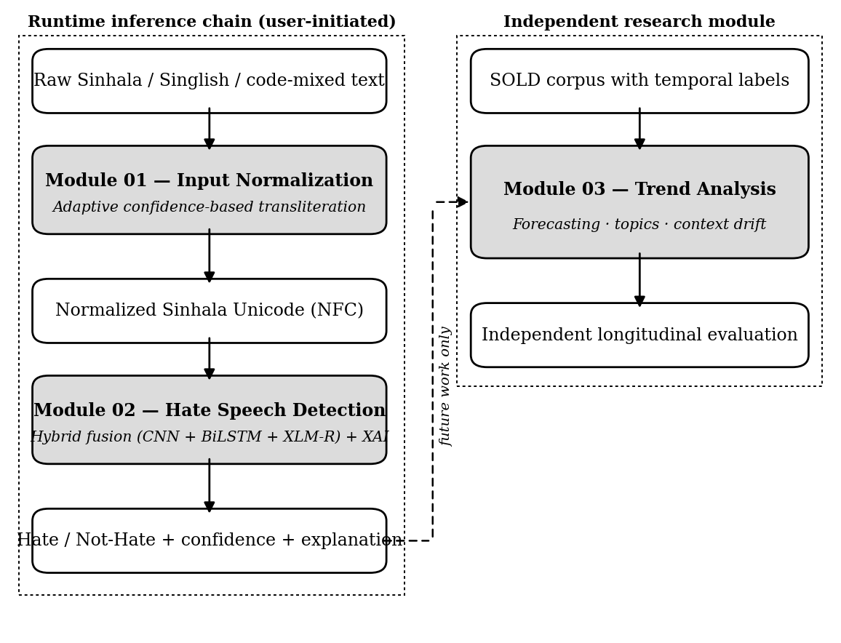
Figure 4.1: Overall architecture of the three-module project
The first one is a runtime inference chain between Module 01 and Module 02. Whether it is typed in Sinhala script, Singlish, Sinhala-English code-mixed text, or a mix, raw social media text is fed into Module 01 which outputs clean, canonically normalized Sinhala script text. That normalized text can be directly used as an input to hate-speech prediction in Module 02. This handoff is made available to the user in the delivered user interface, and is triggered by the user, after normalizing a snippet of text on the Module 01 screen, the user can select to pass the result to the Module 02 detection screen. Each of the two modules serves as a standalone piece of work, and the chain is not a required workflow, but an option.
If there is one, it is deliberate, is about Module 03. The module 03 is an independent research module. It is not a part of the runtime data flow from Module 01 to Module 02 and it is not the next runtime stage after Module 02. It is conducted on its own labelled temporal data set, is tackling a different research question than the other two, and it is assessed separately. The dashed connector in Figure 4.1 represents a future integration where an output of a hate-speech detection system can be fed to a trend-analysis module of this type, which is not part of the current implementation. While all three modules are intended to support the same overall research vision (understanding and countering hateful discourse in Sinhala online space), it is more appropriate to call the project, three related research modules rather than a strict end-to-end execution pipeline.

4.4 Relationship Between the Modules
The difference between training, inference and research scope is easily confused, therefore it is expressed here.
Each module addresses a different research problem and each is trained and developed separately with data pertinent to the problem. Resources to support the development of Module 01 include transliteration, normalization and language-identification. The annotated Sinhala hate-speech corpus is used for training Module 02. Temporal labelling is applied to a corpus for the development of Module 03. There is no claim or research objective used for creating the relationship between the modules, they are just related by the research objective.
Raw code-mixed text can be fed into Module 01 during inference for the purpose of normalizing it into normal Sinhala Unicode, and then fed into Module 02 for the purpose of making a hate or not-hate prediction. This chain is not used in the development of Module 03, which is designed as an analytical module that can analyze the trends of hateful discourse on suitable historical data. This division is all rightfully documented in Table 4.1.
Table 4.1: Training, inference and research scope of each module
Module | Research problem | Training data | Runtime relationship
Module 01 | Normalize Sinhala-English code-mixed text | Transliteration, normalization and language-identification resources | Produces input consumable by Module 02
Module 02 | Detect hate speech in Sinhala text | Annotated Sinhala hate-speech corpus (6,309 comments) | Optionally consumes Module 01 output at inference
Module 03 | Analyze hate-speech trends over time | Labelled corpus with temporal labels (7,500 posts) | None — independent; integration is future work

4.5 Module 01: Adaptive Confidence-Based Input Normalization
The main idea of Module 01 is different from any previous research on South Asian code-mixed text normalization. The system is not just a transliteration system. it is a decision making system that decides whether to transliterate, depending on the token. This is the key research novelty of the module.
The module goes through the following seven stages of processing text, as indicated in Figure 4.2. The text is cleaned, tokenized at script boundaries, each token is given a language label by a priority-ordered identifier, optionally encoded in context by the multilingual transformer, then assigned a calibrated three-class confidence distribution by the Adaptive Confidence Module, routed to one of three actions on the basis of that distribution, then converted to a canonical Unicode form by a hybrid transliterator if and only if the routing decision calls for it, and finally observed by the Adaptive Lexicon Expansion Module, if the routing decision is not resolved.
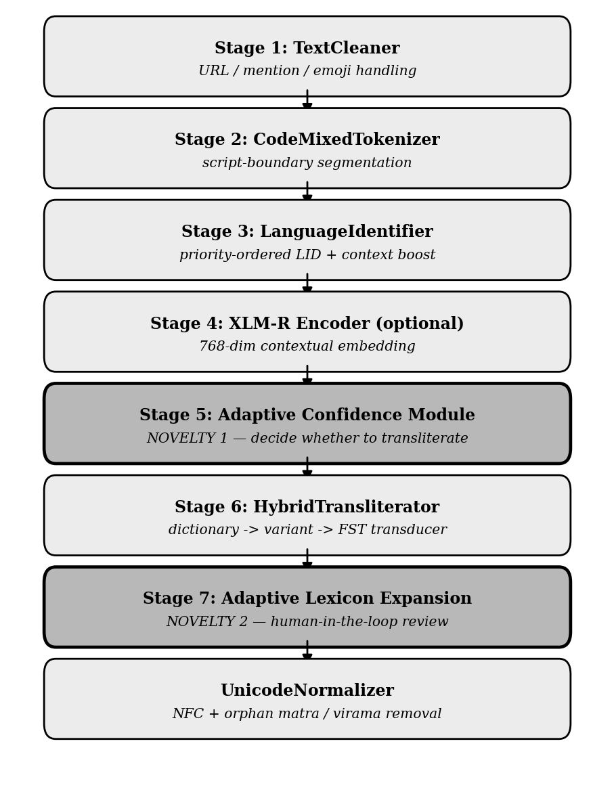
Figure 4.2: The seven-stage normalization pipeline of Module 01
The two stages with thicker borders in Figure 4.2 are the research contributions. The Adaptive Confidence Module generates a probability distribution over the labels Singlish, English and Unknown for each token and uses a threshold policy to send the token to transliteration if the confidence is high, to contextual verification if the confidence is intermediate, to preservation if the confidence is low. The Adaptive Lexicon Expansion Module identifies tokens that were preserved or needed to be verified, counts up the occurrences of those tokens in the corpus, builds up a set of possible dictionary mappings for tokens which occur more than once, ranks possible dictionary mappings, and adds them to a queue for human judgement. Does not write in a production dictionary.
The worked example that inspired the design is used as an example to demonstrate the effect of the design. If a conventional system is used to process the input Ada mama university yanawa, then all four tokens are destroyed, and the English word remains intact. The present system replaces three tokens and retains the fourth token and generates text that has Sinhala text in Sinhala script and English text as a recognisable English word for a downstream model.

4.6 Module 02: Hybrid Fusion Hate Speech Detection
Hate-speech detection is tackled as a combination of complementary evidence in Module 02. It does not rely on any single model, but calculates three perspectives of each comment and fuses them in a fusion layer whose parameters are learned or optimized. The architecture is depicted in figure 4.3.
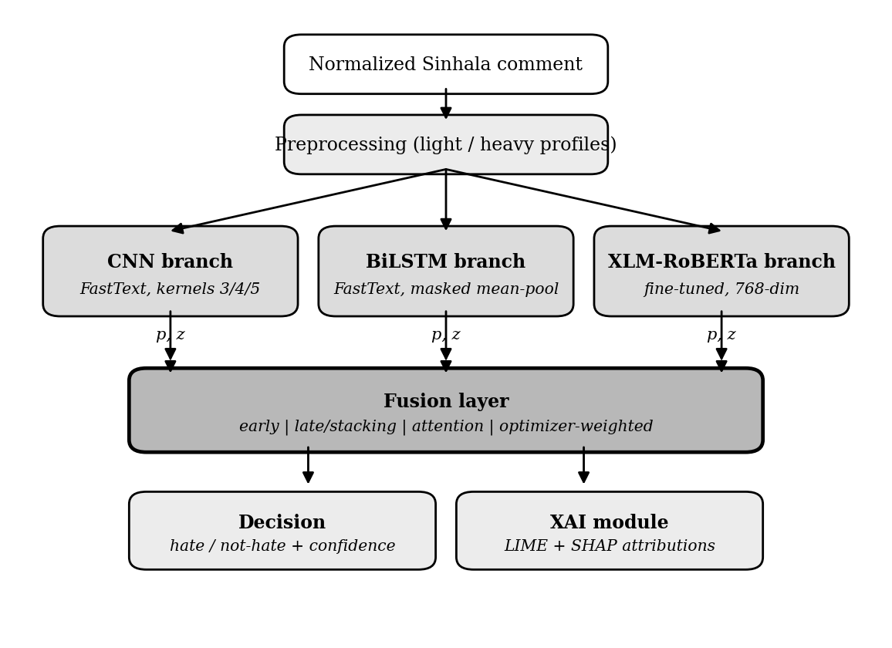
Figure 4.3: Hybrid fusion architecture of Module 02
The design is a hybrid one, as it combines the lexical and contextual approaches of natural language processing in a single system. Lexical branches are good at identifying explicit patterns and are good at handling morphology with sub-word embeddings, but they have a shallow sense of context. The contextual branch is good at meaning and context but it is a single point of failure. The complementary strengths of these are exploited by fusing them, and in the ablation study reported in Chapter 7, it is shown that all three are better together than any subset, and that the contextual branch is essential.
A set of four fusion strategies is designed and systematically compared: early feature-level fusion, late decision-level fusion (including a learned stacking variant), attention-based intermediate fusion, and optimizer-weighted fusion. In all of them, the combination weights are learned using back-propagation, fitted as meta-learner coefficients or picked by an optimization algorithm.
Each prediction is also accompanied by a confidence value, a breakdown of the per-branch predictions of each constituent model, and a word-level explanation generated separately by two model-agnostic methods.

4.7 Module 03: Longitudinal Trend Analysis
Module 03 converts a labelled classification corpus into longitudinal insight. Its pipeline is shown in Figure 4.4. Timestamps are recovered, text is tokenised with a script-aware tokeniser, and posts are resampled into temporal bins carrying a primary signal defined as the proportion of posts in the bin that are hateful. That signal is then analysed along two independent axes.
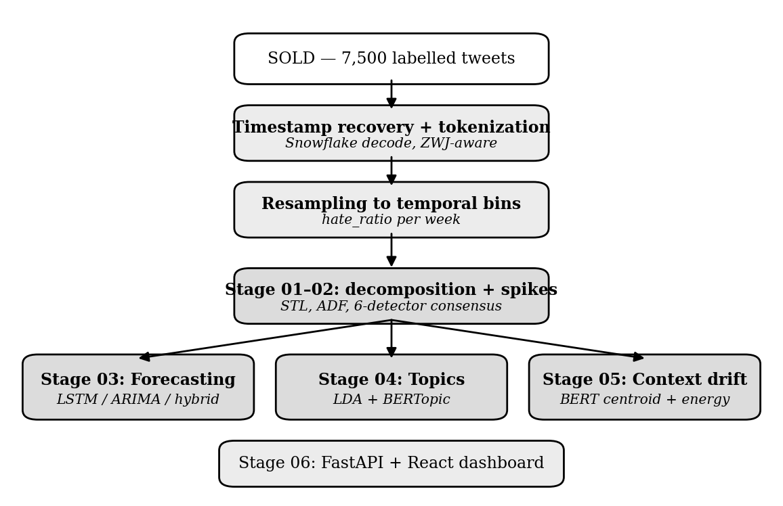
Figure 4.4: Analysis pipeline of Module 03
The conceptual core of the module is the recognition that a stream of hateful discourse has two independent axes: volume, meaning how much hate there is, and meaning, concerning what the hate is about and whether that changes. Prior work measures only volume. By adding the meaning axis, every detected spike can be classified as intensification, in which the same discourse grows louder, or emergence, in which genuinely new discourse appears; and the long-run question of whether hateful discourse has changed or merely grown becomes answerable.
The volume axis is addressed by decomposition and by consensus spike detection across six detectors. The forward-looking question is addressed by a benchmarked forecasting comparison validated by a formal test of predictive accuracy. The meaning axis is addressed by topic modelling, by an embedding-based context-drift analysis validated against permutation nulls, and by a transparent keyword tracker that records which groups are being targeted over time.

4.8 Users, Inputs, Outputs and Process
The proposed system will be used by the content moderators, platform safety analysts, and Sinhala content analysts to analyze Sinhala content from social media platforms. The module 01 is used to normalize the code-mixed Sinhala language text which is then passed to Module 02 for hate speech classification and explanation. Platform analysts can use these modules to process a vast amount of comments, and researchers can use Module 03 to analyze temporal trends and patterns in hateful online discourse. Each module has a description of its inputs, processing, and outputs.

4.8.1 Module 01: Input, Process and Output
Input
The module will accept Sinhala social media text that includes Sinhala Unicode, Singlish (Romanized Sinhala), English words, hashtags, mentions, URLs, emojis and punctuation.
Process
Each token in the input text is preceded by a pre-processing step that cleans the text and tokenizes it. The input text is preprocessed and tokenized before language identification is performed on each token. The proposed transliteration pipeline is used to transliterate Romanized Sinhala tokens into Sinhala Unicode and English words are kept. Lastly, the normalized text is checked and transformed into a consistent Unicode representation.
Output
The module converts Sinhala text to Unicode, which is normalized for downstream processing. Additionally, it offers token-level language identification (LTI) results, transliteration of data, confidence scores, and processing statistics for analysis and debugging.

4.8.2 Module 02: Input, Process and Output
Input
Normalized Sinhala text is provided to the module directly from Module 01 or from a Sinhala data set/ Social context.
Process
The text is preprocessed and then analyzed concurrently with three deep learning models – CNN, BiLSTM, and XLM-RoBERTa. They are fused according to the proposed hybrid fusion architecture to predict the final classification. Then, the prediction is understood via explainable AI methods.
Output
The module will return a binary classification of hate speech, in addition to a confidence score. It also offers explanations created with LIME and SHAP, which reveals the words that made the largest contribution to the prediction.

4.8.3 Module 03: Input, Process and Output
Input
The module takes a list of Sinhala social media posts labeled as hate speech and provided with the time stamps.
Process
The posts are arranged chronologically, and then the temporal patterns of hate speech are identified. The evolution of hateful discourse is analyzed through statistical trend analysis, anomaly detection, forecasting, topic modelling, and semantic drift analysis.
Output
The module provides visualizations and analytical summaries such as trend graphs, detected anomalies, forecasting results, topic evolution, semantic drift measurements, and keyword statistics. These outputs can be used by researchers and policy makers to gain understanding of long-term hate speech behavior.

4.9 Research Novelties
The approach fulfils the above-mentioned gaps of Chapter 2 through eight corresponding novelties, recorded in Table 4.2.
Table 4.2: Research novelties and the gaps they address
Novelty | Description | Gap addressed
N1 — Selective transliteration | Per-token decision about whether to transliterate, driven by a three-class classifier rather than applied uniformly | G1
N2 — Calibrated confidence routing | Threshold policy mapping a calibrated probability to transliterate, verify or preserve, with an explicit Unknown class | G2
N3 — Human-in-the-loop lexicon expansion | Candidate generation and ranking with a review gate that structurally prevents automated dictionary mutation | G3
N4 — Systematic fusion comparison | First systematic comparison of four fusion strategies for Sinhala hate speech | G4
N5 — Heterogeneous hybrid fusion | Fusion of architecturally distinct lexical and contextual branches, with no hand-set weights | G5
N6 — Integrated explainability | Word-level explanation of every decision by two independent model-agnostic techniques | G6
N7 — Benchmarked forecasting | First rigorous forecasting benchmark for Sinhala hate prevalence with scale-free error and a formal significance test | G7
N8 — Context-drift analysis | First test of whether the meaning of Sinhala hateful discourse drifts, triangulated across three measures against permutation nulls, with consensus spike detection | G8

4.10 Summary
This chapter was about the proposed approach. It introduced the overall project architecture by breaking the project into three independent but related research modules instead of a strict end-to-end chain and came up with a careful distinction between the runtime inference chain between Module 01 and Module 02, and the independence of Module 03. It also noted the separation of training data across the three problems. The description of each module was done in outline form, the users of the modules were identified, the inputs, outputs and process for each module were described, and eight research novelties were mapped to the eight gaps defined in Chapter 2. Four methodological principles were laid down for the work. The detailed analysis and design of each module is presented in the next chapter, along with the interface contract for the handoff between Modules 01 and 02.

CHAPTER 5 – ANALYSIS AND DESIGN

5.1 Introduction
The approach proposed in the previous chapter was presented and the relations among the three modules were set. This chapter is an analysis and design that achieves that approach. It starts with the system architecture (at the highest level) and the requirements analysis, follows with the detailed design of each module, specifies the interface contract that governs the runtime interface between the two modules (01 and 02), and ends with the user-interface design. The focus is on the function of each object and how it relates to the others throughout; how each was constructed is detailed in Chapter 6.

5.2 High-Level System Architecture
The overall system design of the proposed system was given in Figure 4.1 of the previous chapter. It is a three-module course. The input normalization module is called Module 01. It can process raw text from social media platforms using both Sinhala and English characters, including code-mixed and Singlish (Romanized Sinhala) content and delivers normalized Sinhala Unicode text as output to the downstream hate speech detection system. The detection module (Module 02) takes the input text in Sinhala and outputs the label hate/not-hate with a confidence value and a word level explanation. The trend-analysis module (module 03) takes an annotated corpus with timestamps as input and outputs decomposed series, identified peaks, projections, topic models, and drift analyses.
The relationship between Module 01 and Module 02 is a runtime relationship, as detailed in the Upcoming Section. In the current realization, Module 03 is developed and evaluated separately from other modules, except for interaction with others. Each module is internally broken into sub-modules, and those decompositions are discussed in Upcoming Sections.

5.3 Requirements Analysis

5.3.1 Functional Requirements
Table 5.1 records the functional requirements of the system, their priority, and the component that satisfies each. Requirements are grouped by module.
Table 5.1: Functional requirements
ID | Requirement | Priority | Satisfied by
FR-01 | Accept raw social media text and return normalised output | Must | Module 01 pipeline
FR-02 | Remove URLs, mentions, hashtags and repeated characters | Must | TextCleaner
FR-03 | Split tokens at script boundaries | Must | CodeMixedTokenizer
FR-04 | Assign each token a language label | Must | LanguageIdentifier
FR-05 | Compute a calibrated confidence score per token | Must | AdaptiveConfidenceModule
FR-06 | Route tokens to transliterate, verify or preserve | Must | Threshold policy
FR-07 | Convert romanised Sinhala using dictionary then transducer | Must | HybridTransliterator
FR-08 | Preserve English tokens unchanged in the output | Must | Decision policy
FR-09 | Track novel tokens and generate candidate mappings | Should | AdaptiveLexiconExpansion
FR-10 | Provide a human review interface for candidates | Should | Review queue interface
FR-11 | Apply canonical normalisation and validate sequences | Must | UnicodeNormalizer
FR-12 | Operate without transformer download in rule-based mode | Must | Lazy loading
FR-13 | Classify a Sinhala comment as hate or not-hate | Must | Module 02 fusion layer
FR-14 | Return a confidence value with every prediction | Must | Fusion output
FR-15 | Return a per-branch probability breakdown | Should | Branch caching layer
FR-16 | Return a word-level explanation of every prediction | Must | XAI module
FR-17 | Accept Module 01 output directly as detection input | Must | Interface contract
FR-18 | Decompose the hate signal into trend and seasonal parts | Must | Module 03 stage 01
FR-19 | Detect anomalous periods by detector consensus | Must | Module 03 stage 02
FR-20 | Forecast future prevalence against naive baselines | Must | Module 03 stage 03
FR-21 | Produce interpretable topics over hateful posts | Should | Module 03 stage 04
FR-22 | Test whether the meaning of hate drifts over time | Must | Module 03 stage 05
FR-23 | Expose all results through interactive interfaces | Should | Streamlit and dashboard

5.3.2 Non-Functional Requirements
Table 5.2 records the non-functional requirements and the target against which each is assessed.
Table 5.2: Non-functional requirements
ID | Requirement | Target
NFR-01 | Rule-based normalisation latency per sentence | Under 50 ms, no graphics processor
NFR-02 | Neural normalisation latency per sentence | Under 500 ms with graphics processor
NFR-03 | Automated test suite pass rate | 100 per cent
NFR-04 | Production dictionary never modified automatically | Zero automated writes (invariant)
NFR-05 | English words preserved without corruption | Preservation accuracy at least 0.95
NFR-06 | Transformer loaded only when requested | No model load on import
NFR-07 | Canonical normalisation applied to all output | 100 per cent compliant output
NFR-08 | Detection inference without a graphics processor | Standard processor, cached branches
NFR-09 | Reproducibility of reported results | Single seed governs all stochastic operations
NFR-10 | Leakage safety in evaluation | Test partition untouched during selection
NFR-11 | Modularity of code structure | No circular imports; clean interfaces
NFR-12 | Correct rendering of Sinhala in all interfaces | Full UTF-8 support

5.4 Design of Module 01: Input Normalization

5.4.1 Pipeline Stage Design
The seven stages of Module 01 are independently testable and presented in Figure 4.2. Communication between stages happens in a structured way with a defined structure and data, not directly via raw dictionaries, thus enforcing type safety and each interface is self-documenting.
The TextCleaner performs several regular-expression transformations on raw social media text: it removes the uniform resource locators, it removes mentions and hashtags, it normalises or removes emoji (where they're repeated, only the first is kept) and it caps the number of times a character is repeated in a row (a common social media noise pattern in which a character is repeated with emphasis). The cleaner carefully ensures that Sinhala characters are not lowercased, by separating the text into Sinhala and non-Sinhala spans and only lowercasing the latter.
The CodeMixedTokenizer tokenizes the text based on the boundaries between the runs of Latin script and Sinhala script, followed by tokenization based on whitespace and punctuation. Every generated token includes its character offsets in the input string, allowing an exact sub-word alignment and byte-accurate reconstruction when using the transformer to encoder.
The Language Identifier imposes a strict priority ordering which will help to reduce false positive results. Immediate full weight classification of tokens with Sinhala characters. The next tokens are numeric and punctuation. Thereafter, exact matches are made against the Singlish dictionary and the English wordlist. If all these lookups fail, the identifier resorts to morphological heuristics: Sinhala verb and noun suffixes, Sinhala consonant-cluster patterns used in Sinhala phonology and finally to English derivational suffixes. Tokens that have passed through all of the stages are classified as mixed. A context-window method then boosts the confidence of ambiguous tokens based on the languages of their neighbors in a window of two tokens around them.

5.4.2 Formulation of the Adaptive Confidence Module
Tokenize a sentence into a sequence of tokens. For each token the Adaptive Confidence Module must produce a probability distribution over the three labels Singlish, English and Unknown; a scalar confidence score; and a routing decision. The distribution is calculated using a three-layer perceptron on a feature vector concatenated as described in Equation 5.1.
P(t) = softmax(W3 · GELU(W2 · LayerNorm(W1 · φ(t) + b1) + b2) + b3) (5.1)
where the feature vector for a token lies in a nine-hundred-and-sixteen-dimensional space. The probability of the Singlish class is used as the confidence score, as in Equation 5.2.
c(t) = p_singlish(t) (5.2)
The routing decision is based on the threshold policy given by equation 5.3 with the upper threshold at 0.90 and the lower threshold at 0.60.
d(t) = TRANSLITERATE if c(t) ≥ 0.90; VERIFY if 0.60 ≤ c(t) < 0.90; PRESERVE otherwise (5.3)
The architecture of the classifier is displayed in Figure 5.1. Normalization over the feature dimension is deliberately selected over batch dimension because of the following reasons: (1) It does not rely on the number of samples in a batch and hence is suitable for streaming mode inference (where a pipeline is called once per sample); (2) It does not require a large batch size as is the case with batch normalization.
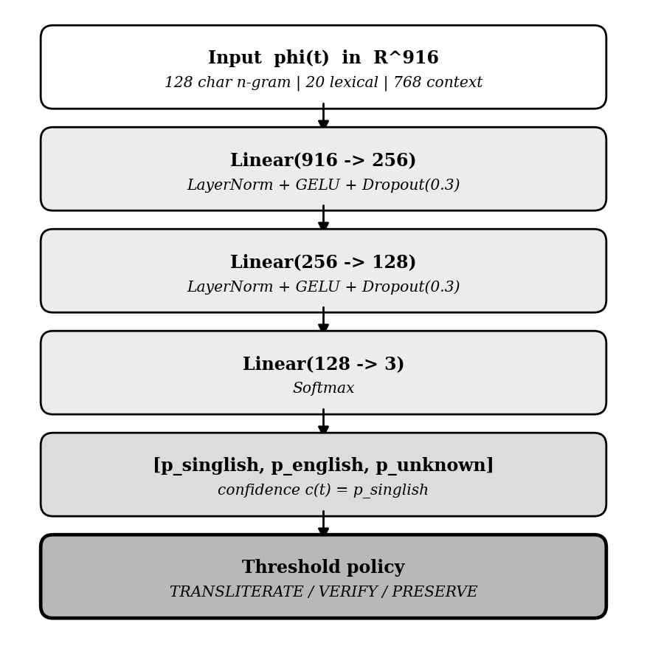
Figure 5.1: Architecture of the confidence classifier

5.4.3 Feature Vector Design
The feature vector is the concatenation of three independently computed sub-vectors, as given in Equation 5.4: a character n-gram hash vector of one hundred and twenty-eight dimensions, a hand-crafted lexical vector of twenty dimensions, and a contextual embedding of seven hundred and sixty-eight dimensions.
φ(t) = [ φ_char(t) ‖ φ_lex(t) ‖ φ_ctx(t) ] (5.4)
Each of the lowercased token's character n-grams (where n=2, 3, 4) is hashed to a bucket index using a polynomial hash, as described in Equation 5.5. These bucket counts are then re-normalized in terms of unit length, with the aim of getting vectors of similar length from long and short tokens.
h(g) = ( Σ ord(g_i) · 31^(|g|−i−1) ) mod D, D = 128 (5.5)
The number of 128 buckets is a compromise between the number of collisions and the dimensionality. The expected number of tokens in a bucket is low for tokens of the length found in the Sinhala register, as it is usually from three to ten characters.
The lexical feature vector represents the membership of a dictionary, morphological patterns, phonological heuristics, and character level statistics. It has twenty parts which are listed in Table 5.3. The features that enable the classifier to discriminate on morphology, not just on vocabulary, are encoded in components 9–12, which encode Sinhala morphological suffixes, and components 13–15, which encode English derivational suffixes.
Table 5.3: Components of the lexical feature vector
# | Feature | Description | Range
0 | in_singlish_dict | Token appears in the Singlish dictionary | {0, 1}
1 | in_english_words | Token appears in the English wordlist | {0, 1}
2 | token_length_norm | Token length normalised and clamped | [0, 1]
3 | vowel_ratio | Proportion of characters that are vowels | [0, 1]
4 | consonant_ratio | Proportion of characters that are consonants | [0, 1]
5 | has_repeated_consonant | A consonant appears twice consecutively | {0, 1}
6 | starts_with_upper | First character is uppercase | {0, 1}
7 | all_upper | All characters are uppercase | {0, 1}
8 | has_digit | Token contains at least one digit | {0, 1}
9 | ends_nawa | Sinhala present-tense suffix | {0, 1}
10 | ends_la | Sinhala anterior suffix | {0, 1}
11 | ends_da | Sinhala interrogative suffix | {0, 1}
12 | ends_wath | Sinhala emphatic suffix | {0, 1}
13 | ends_ing | English gerund suffix | {0, 1}
14 | ends_tion | English nominaliser suffix | {0, 1}
15 | ends_ly | English adverbial suffix | {0, 1}
16 | has_sinhala_cluster | Contains a Sinhala consonant cluster | {0, 1}
17 | unique_char_ratio | Ratio of distinct characters to length | [0, 1]
18 | lid_confidence | Confidence from language identification | [0, 1]
19 | lid_is_sin | Language identification label is Sinhala | {0, 1}
In the neural mode, the transformer representation of the target token in its sentence is extracted and averaged over the sub-word units to generate the contextual sub-vector. This sub-vector is zero in rule-based mode, and decisions are made based on a deterministic decision logic described below.

5.4.4 Rule-Based Decision Logic
The module is in rule-based mode before any training data becomes available, and it has a deterministic decision procedure on the language-identification result and the lexical features. This addresses the cold start issue: the system can be fully operational from deployment day 0 without the need for a labelled training corpus. The procedure is provided in Figure 5.2.
Figure 5.2 - Rule-based confidence decision

5.4.5 Verification Resolution Policy
Intermediate verification decision tokens can't be sent on to either action until more information is received. They are resolved by the pipeline, which keeps a context window of 2 tokens for each token and slides it across the Sinhala token window to find the number of tokens that are identified as Sinhala, as shown in Equation 5.6.
sin_count(i) = | { j : |j − i| ≤ 2, j ≠ i, lid(t_j) ∈ {SIN, SIN_UNICODE} } | (5.6)
If this count is greater than 0, then the verified token will be transliterated; otherwise, it will be preserved. The policy reflects a true sociolinguistic regularity: in Singlish sentences, English words are more likely to be isolated, surrounded by Sinhala tokens, while ambiguous tokens that occur in completely English sentences are much more likely to be English.

5.4.6 Design of the Adaptive Lexicon Expansion Module
Social media has its own ever-changing lexicon. New romanisation methods, borrowings, slang, abbreviations come faster than any dictionary can catch up. The lexicon needs to expand, however, and expansion through unsupervised mutation would add errors to the only source for the entire module. The Adaptive Lexicon Expansion Module overcomes this tension by providing a closed loop discovery-to-review pipeline with a required human gate, as depicted in Figure 5.3.
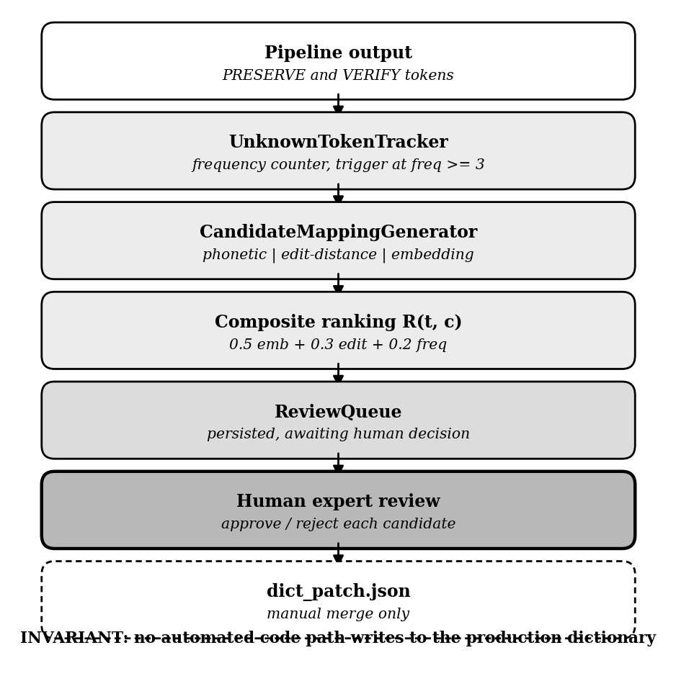
Figure 5.3: Design of the adaptive lexicon expansion module
The production dictionary is never changed by any automated process – this is an invariant that governs the whole design. Any changes must be made in the review queue and then manually applied by exporting a patch file. This is made structurally, not convention, so there are no code paths that write the production dictionary file, and the approval method does not commit; it just returns the approved entry back to its caller.
Three strategies are implemented to generate candidate mappings: Direct phonetic transduction of the unknown token, Edit-distance searching of dictionary items within a bounded Levenshtein distance, and Embedding similarity against known items (when the encoder is available). Candidates are sorted in order of the composite score of Equation 5.7.
R(t, c) = α · sim_emb(t, c) + β · (1 − edit_norm(t, c)) + γ · freq_norm(t) (5.7)
Using default weights of 0.5, 0.3, and 0.2 respectively. A token is only generated when it has been observed at least once, so that the queue does not become full of typographical errors that are only seen once and not again. The procedure is as follows; The procedure is provided in Figure 5.4.
def observe(self, token: str, context: Optional[str] = None) -> None:
"""
Record an observation of a token that was preserved (not transliterated).
This is the entry point for unknown-token discovery.
"""
lower = token.lower().strip()

# Skip if already in known dictionary
if lower in self.singlish_dict:
return

# Skip Sinhala Unicode (already in target script)
if _SINHALA_RE.search(token):
return

# Skip pure numerics and punctuation
if not any(c.isalpha() for c in token):
return

self.tracker.observe(lower, context)
Figure 5.4 - Adaptive lexicon expansion

5.4.7 Data Design
The production Singlish dictionary maintains a flat dictionary of Romanized-to-Unicode mappings, including a metadata header which documents the version, encoding and number of entries in the dictionary. The training data for the confidence classifier are a set of token records with a gold label, containing sentence, expected Sinhala form (if it exists), and context tokens. Label encoding is done as integer labels, and feature tensors are precomputed during the dataset building process, thus avoiding the need to recompute the transformer embeddings at each epoch.

5.4.8 Component Architecture and Interfaces
Module 01 is broken down into nine modules that have a strictly layered dependency, as illustrated in Figure 5.5. Each component imports nothing from other components that are above it in the graph, or from the configuration layer, therefore no circular dependency. This meets requirements, and more significantly, it allows for testing individual components using mock inputs, as described in Chapter 6, which enables the creation of the sixty-one-test suite.
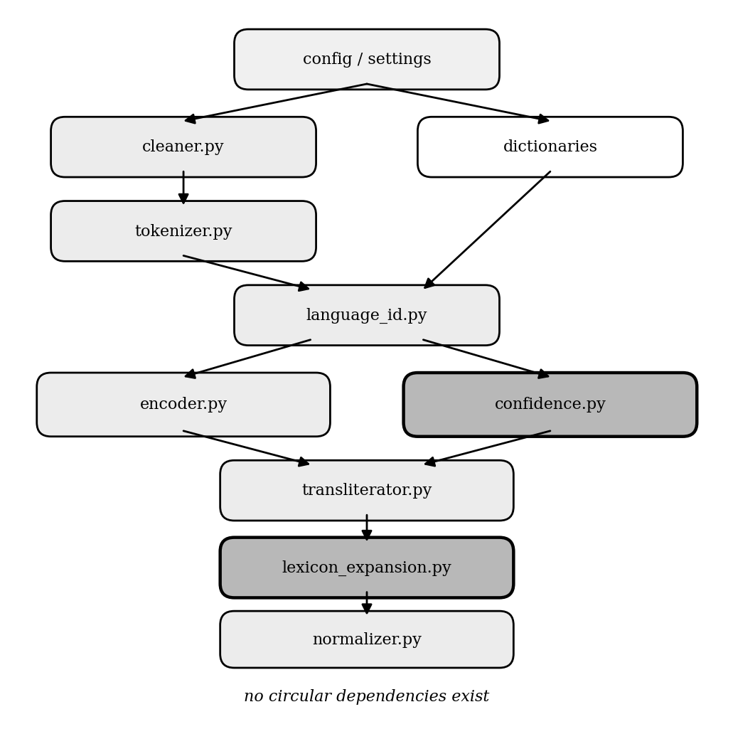
Figure 5.5: Component dependency graph of Module 01
The components exchange information via explicitly defined structured records, not by using untyped dictionaries. This decision will be paid for with a bit of boilerplate, but there are two benefits: the interface between any two stages is self-documenting, and a change to the shape of output of one stage will fail at the boundary, not propagate silently into the next stage. The principal records and the stage in which each is created are shown in Table 5.4.
Table 5.4: Inter-stage data records of Module 01
Record | Produced by | Principal fields
Token | CodeMixedTokenizer | text, index, character offsets, script and type flags
LIDResult | LanguageIdentifier | token, label, confidence, contributing signals
TransliterationDecision | AdaptiveConfidenceModule | token, class probabilities, confidence, decision, reason
TransliterationResult | HybridTransliterator | source, Sinhala form, method used, success flag, confidence
CandidateEntry | CandidateMappingGenerator | token, proposed mapping, strategy, ranking score
TokenResult | Pipeline | original, normalised, decision, label, confidence, method
PipelineResult | Pipeline | original, normalised, token results, statistics, elapsed time
This structure has two design implications that are worth discussing explicitly. First, the decision module returns a decision record containing the reason of the decision instead of just the action, thus the interface can show to the user not only what the system does with each token, but also why, which is how the per-token table described in Section 5.8 is filled. Second, downstream consumers that only want the string can ignore the remainder of the pipeline's result, and the lexicon expansion module can process the trace without re-running the analysis.

5.5 Design of Module 02: Hate Speech Detection

5.5.1 Dataset Analysis
There are 6,345 comments in the corpus, but thirty-six of them were exact duplicates and have been removed, leaving 6,309 comments. There is a slight imbalance in the class distribution with 54.6 per cent of the classes being hateful and 45.4 per cent not hateful as can be seen in Figure 5.6. Comments are brief with a mean length of about twelve words and a ninety-fifth percentile of forty-one words (see Figure 5.7 for a distribution by class). The corpus is 99.3 per cent Sinhala script with only 2.3 per cent code-mixing.
Figure 5.6: Class balance of the detection corpus
Figure 5.7: Distribution of comment length by class
The most common tokens per class were analyzed and neutral tokens were found that were used by both classes, as well as hate-class slurs, which indicates that lexical cues do exist but are not enough without context. These observations led to three design decisions. Three design decisions were made based on these observations. The choice of macro-averaged F1 as the primary measure was due to the imbalance. No attempt was made to balance the classes by resampling, as class weights were calculated from the data. The maximum sequence length of one hundred and twenty-eight sub-word tokens was selected as sufficient, based on the lengths of observed comments.

5.5.2 Preprocessing Design
Two pre-processing profiles have been developed; one for transformers and one for statistical representations. The light profile performs canonical normalization, eliminates zero-width joiners, substitutes URLs, mentions and numbers with placeholder tokens, leaves emoji as tokens, and collapses character elongation. It maintains context and is utilized by deep branches. The heavy profile adds punctuation removal, mapping of emoji to sentiment tokens and more aggressive normalization and is used by the classical baselines. Heavy profile stop word removal is not assumed to be useful but is considered to be a tunable option.

5.5.3 Feature and Embedding Design
The classical branch is a statistical vector that consists of word n-grams of length 1 and 2 and character n-grams of length 2-5, all scaled sub-linearly by the term frequencies. The word component captures explicit human readable terms, while the character component captures the sub-word morphological regularities that are crucial for Sinhala. Both are kept on principle and their relative contribution is looked at by ablation in Chapter 7. Table 5.5 provides a summary of the three representations that were employed throughout the module.
Table 5.5: Embedding and feature representations
Representation | Type | Used by | Dimensionality
Word and character n-grams | Sparse, statistical | Classical baselines | 41,800 features
FastText Sinhala vectors [3] | Static, sub-word | CNN and BiLSTM branches | 300 per word
XLM-RoBERTa [5] | Contextual | Transformer branch | 768 per comment

5.5.4 Classical Baseline Design
Three classical baselines were created on top of the statistical representation, logistic regression (with second-order regularization and balanced class weights); linear support vector machine (with probability calibration); and gradient-boosted trees (with a scaling factor derived from the data). Regularization strength of the linear models is determined using the cross-validated grid search. The baselines set forth the performance that the deep and fusion models must be able to outperform to justify the added complexity.

5.5.5 Deep Branch Design
Three deep branches have been designed. The convolutional branch uses 1D convolutions with kernel width of 3, 4 and 5 on the embedding sequence and then performs max-over-time pooling to identify the most salient local n-gram patterns. The recurrent branch reads the embedding sequence in both directions and performs masked mean-pooling across valid positions, to capture word order and sequential context. The transformer branch is optimized using class-weighted cross-entropy, linear warm-up learning rate, gradient clipping, and early stopping based on the macro-F1 score on the validation set.
Two outputs of each branch are fed into the fusion layer, such as a hate probability and a penultimate feature vector, with one hundred and ninety-two and two hundred and fifty-six and seven hundred and sixty dimensions, respectively.

5.5.6 Fusion Layer Design
Four fusion strategies were designed and compared. In all of them the combination weights are learned or optimized.

Early feature-level fusion
The penultimate feature vector is normalized to unit length, the three are then concatenated together into a one thousand two hundred and sixteen dimensional vector, which is fed into a multilayer perceptron whose weights are trained using back-propagation.

Late decision-level fusion
The three branch probabilities are added together. Parameter-free variants: arithmetic mean, maximum, or geometric mean. The learned variant, stacking, is a logistic-regression meta-learner that is fitted on validation probabilities, and whose fitted coefficients quantify the amount of trust placed on each branch by the fusion.

Attention-based intermediate fusion
All features are mapped to a common space, a small network computes a gate score for each branch, these scores are normalized using a softmax to get per-comment weights, and the fused representation is a weighted sum of the features. All parameters learned end to end. Each gate is different, and is used to explain what the branch was that made each particular decision.

Optimizer-weighted fusion
A weighted sum of branch probabilities is formed using weights constrained to the simplex, and a tuned decision threshold is applied. The weights are searched to maximize validation macro-F1 by both Bayesian optimization [1] and the Grey Wolf Optimizer [21].

5.5.7 Hyperparameter Optimization Design
The hyperparameters of the convolutional branch and the recurrent branch were optimized using Bayesian optimization, maximizing the macro-F1 score on the validation set, and they were then set for all the remaining experiments. The selected configurations are given in Table 5.6. It is important to note that the optimizer chose learning rates that are much lower than the default, which has been noted to be too high and cause overfitting; this is a real-world reason why systematic optimization is better than the “standard” approach.

Table 5.6: Hyperparameters selected by Bayesian optimization
Model | Filters / hidden | Layers | Dropout | Frozen embeddings | Learning rate | Validation macro-F1
CNN | 64 | 3 kernels (3, 4, 5) | 0.53 | No | 2.8 × 10⁻⁴ | 0.876
BiLSTM | 128 | 1 | 0.44 | No | 8.2 × 10⁻⁴ | 0.869

5.5.8 Evaluation Design
The main performance measure is macro-averaged F1, which is used to cope with the mild class imbalance. The other metrics are secondary metrics: accuracy, per-class precision, recall and F1, area under receiver operating characteristic curve, and area under precision-recall curve. McNemar's test and a paired bootstrap on a single frozen split are used to assess statistical significance as are a paired t-test, Wilcoxon signed-rank test and Cohen's d effect size over five-fold stratified cross validation.

5.5.9 Explainability Design
The explainability module is a wrapper that allows both attribution methods to modify the input to the fusion model and see how it responds. The model's tokenizer is not used to tokenize the text for explanation, but rather whitespace is used, meaning that whole Sinhala words are assigned, not the split parts of words at combining marks, which has a significant impact on whether or not the explanation is understandable to a moderator. The module returns the top words that most increased and most decreased the predicted hate probability.

5.6 Design of Module 03: Trend Analysis

5.6.1 Dataset and Signal Design
The trend-analysis module operates on the Sinhala Offensive Language Dataset [24], comprising 7,500 labelled posts. Coverage spans 2015 to 2022, yielding 366 weekly bins containing 3,176 hateful posts across twenty-nine usable quarters. Derived fields include a timestamp recovered from the post identifier, a binary hate indicator, a severity tercile and extracted hashtags.
The primary signal is the hate ratio: the number of hateful posts in a bin divided by the total number of posts in that bin. Using a ratio rather than a raw count normalises out changes in overall posting activity, so that a rise reflects a genuine change in the proportion of hateful discourse rather than a general increase in volume of posting. Figure 5.8 shows the resulting weekly signal with its rolling mean and the periods subsequently identified as high-confidence spikes.
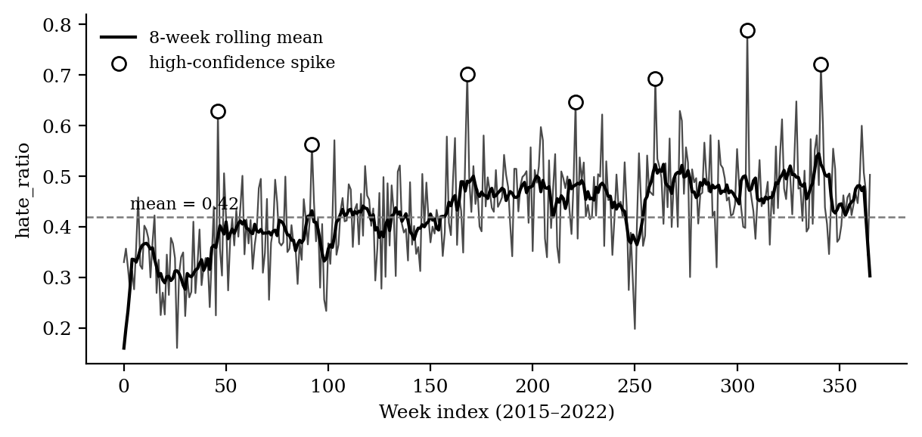
Figure 5.8: Weekly hate-ratio signal with rolling mean and detected spikes
An honest limitation must be recorded at the design stage. This corpus is a classification sample rather than a complete timeline of Sinhala social media activity. All trend, forecast and drift results are therefore presented as a validated method together with preliminary results, and full-corpus validation is identified as further work.

5.6.2 Analysis Stage Design
Six analysis stages were designed. The first decomposes the weekly signal into trend, seasonal and residual components and tests for stationarity. The second detects anomalous periods using six detectors in parallel, described in Table 5.7, with a period counted as a high-confidence spike only when at least two detectors agree. The third benchmarks three forecasters against two naive baselines. The fourth produces topic models by two independent methods. The fifth tests whether the meaning of hateful discourse drifts. The sixth exposes all cached results through a dashboard.

Table 5.7: The six spike detectors fused by consensus
Detector | Family | Principle
Z-score | Statistical | Standard deviations above the global mean
Interquartile range rule | Statistical | Beyond the upper quartile plus 1.5 times the interquartile range
Rolling standard deviation | Statistical | Unusual relative to a local eight-week window
Cumulative sum | Change-point | Cumulative sustained deviation rather than single excursions
Isolation Forest [19] | Machine learning | Point isolated in feature space by few random partitions
Recurrent autoencoder [13] | Deep learning | High reconstruction error indicates an anomaly

5.6.3 Evaluation Design
Four design decisions govern the evaluation of this module. A temporal hold-out reserves the final fifth of the weeks, with models trained only on earlier data. A walk-forward backtest predicts each test week one step ahead, refitting as data arrives, so that no look-ahead leakage is possible. Permutation nulls are constructed by shuffling timestamps repeatedly to establish the distribution of drift expected by chance. And triangulation requires that three independent drift measures agree before any stability claim is made.

5.7 Interface Contract Between Module 01 and Module 02
This section specifies the contract governing the runtime handoff between the normalization and detection modules, and states its known limitation. Figure 5.9 summarises it.
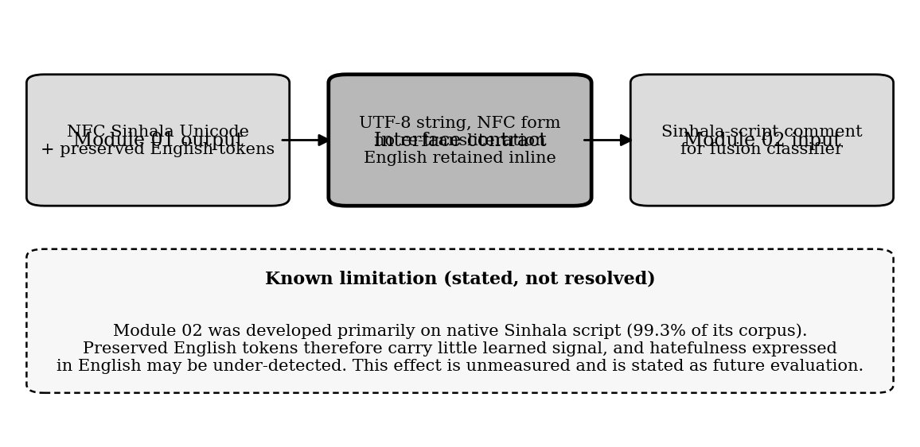
Figure 5.9: Interface contract between Modules 01 and 02

5.7.1 What Module 01 Emits
In Module 01, a string of text is generated that has 3 properties defined. Sinhala Unicode in canonical composed form, that is no sequence has an alternative byte representation. Preserves the English tokens which the confidence module has decided to keep as is and in-line. It is also clean, normalised text that's fit for natural language processing further down the line, with boilerplate text removed and characters elongated.

5.7.2 What Module 02 Accepts
Module 02 accepts this normalized text directly as the input to hate-speech prediction. No intermediate transformation is required, no re-transliteration is performed, and the string is passed to the preprocessing stage of the detection pipeline exactly as emitted.

5.7.3 Known Limitation
As per the information in Section 5.5.1, the training corpus used in module 02 comprises mainly of Sinhala Unicode text (99.3 per cent), with only 2.3 per cent code-mixing. As such the English tokens that Module 01 intentionally saves reflects a small distribution gap between the text that Module 02 was trained on and the text it gets in this interface.
The mechanism needs to be precise, as the effect is easily misdescribed. The preserved English Tokens are not skipped or ignored in Module 02; it gets the whole string and processes the whole string. What happens is that its learned representations have little signal for those tokens since the static Sinhala embeddings do not have any meaningful vector for an English word and the fine-tuned transformer did not have much English in fine-tuning. The practical implication is specific: hatefulness in the remaining English component of a comment may be under-detected, compared to hatefulness in Sinhala.
Preserving English is still the right approach and it's a purposeful approach. The alternative transliterating authentic English words would result in approximations that no downstream model would recognize, the very failure mode that was identified in Chapter 2, and the failure this project set out to eliminate. The distribution difference is the cost of avoiding greater harm, which is accepted.
This effect has not been measured experimentally in the present work. It is therefore stated here as a known limitation and identified in Chapter 7 as something that could be evaluated in the future, rather than as a solved problem.

5.8 User Interface Design
Three interfaces have been designed, one for each module, and a handoff between the first two.
There are four screens in the normalization interface: a live processing screen where a user enters text and displays the normalized output, with an option to view a per-token table of decisions and confidence scores; a batch screen; a lexicon review screen in which the user can see the queue of candidates and approve or reject them, and export patches; and a configuration screen in which the user can view the thresholds. Most importantly, the user can select to pass the normalized output to the detection interface as it is, which is the way the interface contract of Section 5.7 is used in practice.
The detection interface displays three screens – an evaluation screen which displays all results and a significance verdict, a prediction screen that accepts a comment and returns a label, a confidence and a breakdown per branch, and an explanation screen which shows word-level attributions from both techniques side by side.
The trend-analysis interface is a single-page application that is served via a read-only application programming interface (API) with roughly two dozen endpoints. It has five tabs; overview, forecast, topics, context drift and chart gallery, and explains what each chart represents next to them. Sinhala is correctly displayed in all three interfaces.

5.9 Summary
The analysis and design of the system has been presented in this chapter. It provided the functional and non-functional requirements, and then detailed design of each of the three modules: seven-stage normalization pipeline and its confidence formulation, feature design, decision logic and human-gated lexicon expansion; detection module and its dataset analysis, dual preprocessing profiles, three deep branches and four fusion strategies; trend-analysis module and its signal design, six-detector consensus and evaluation design. It then outlined the interface between Module 01 and Module 02, and made a clear statement of the distribution difference caused by the use of preserved English tokens and the rationale for accepting the difference. The chapter ended with the user-interface design. Each of the above designs is implemented in the next chapter.

Chapter 6 – Implementation

6.1 Introduction
In the last chapter, the design of each of the three modules was presented. This chapter outlines the implementation of those designs, while keeping the components mentioned in the design designating the same components described here. It outlines the development environment and tools, and then follows the implementation of each of the modules in the sequence of the design, highlighting key algorithms and code snippets.

6.2 Implementation of Module 01: Input Normalization

6.2.1 Text Cleaning
The cleaner performs a series of regular expression changes. Special consideration is given to the preservation of Sinhala characters in lowercasing. The standard lowercasing operation is safe for Sinhala, but custom logic is used to split the text into Sinhala spans and non-Sinhala spans, and to perform the lowercasing only on the latter, avoiding edge cases due to combining characters. The selective lowercasing routine is listed in the following routine (Listing 6.1).
LISTING 6.1 - Selective lowercasing preserving Sinhala spans

SINHALA_RANGE = re.compile(r'[\u0D80-\u0DFF]+')

def _selective_lower(text: str) -> str:
parts = SINHALA_RANGE.split(text)
matches = SINHALA_RANGE.findall(text)
result = []
for i, part in enumerate(parts):
result.append(part.lower())
if i < len(matches):
result.append(matches[i]) # preserve Sinhala as-is
return ''.join(result)
Repeated character normalisation enforces a limit of two characters for any run longer than two. This is used after URL and mention removal to prevent the accidental collapse of URL paths.

6.2.2 Tokenisation
The tokeniser splits the text between the runs of the Sinhala script and non-Sinhala non-whitespace runs based on a compiled regular expression which matches either Sinhala run or non-Sinhala non-whitespace run or whitespace run. The tokens are embedded in a structured record that includes character offsets, allowing the original text to be byte-accurately reconstructed and precise sub-word alignment in the encoder.
LISTING 6.2 - Script-boundary segmentation

SEGMENT_RE = re.compile(
r'([\u0D80-\u0DFF]+|[^\u0D80-\u0DFF\s]+|\s+)'
)

6.2.3 Language Identification
The identifier is an implementation of the priority stack described in Section 5.4.1. Sinhala script tokens are classified immediately with full confidence, followed by numeric and punctuation tokens, followed by exact dictionary match with the set of Sinhala words followed by wordlist match with a set of English words, followed by matching known verb and noun suffixes and consonant-cluster patterns in Sinhala, followed by matching known English derivational suffixes, and finally a mixed fallback. For a mixed token, the context method gives a boost of 0.15 if two or more of the neighbors in the window are predominantly Sinhala.

6.2.4 The Adaptive Confidence Module
The confidence module is the most complex module in Module 01, and will be responsible for three different execution paths: rule-based, neural single-token and neural batch. The character feature extractor uses the polynomial hash defined in Equation 5.5, with an explicit loop over the n-grams, and then normalisation to unit length. The loop is not vectorised on purpose since it would be much more expensive to construct an array of such short tokens as this is the case. Listing 6.3 shows the extractor.
LISTING 6.3 - Character n-gram hash feature extractor

def extract(self, token: str) -> np.ndarray:
token = token.lower()
vec = np.zeros(self.feature_dim, dtype=np.float32)
for n in self.ngram_sizes: # [2, 3, 4]
for i in range(len(token) - n + 1):
gram = token[i:i + n]
h = 0
for ch in gram:
h = (h * 31 + ord(ch)) % self.feature_dim
vec[h] += 1.0
norm = np.linalg.norm(vec)
return vec / norm if norm > 1e-9 else vec
Neural mode: The module builds the complete feature tensor, feeds it into the perceptron with the model in evaluation mode with the gradient computation disabled, and applies the threshold policy to the output distribution. A batch method is a method where a list of tokens is processed in a single forward pass, significantly decreasing the latency for processing multiple sentences.

6.2.5 The Hybrid Transliterator
The transliterator supports four levels of fall back. First level: Lowercases the string and then looks it up in the dictionary, returning as soon as a match is found. The second attempts a limited number of familiar romanization variants, most notably the doubling and undoubling of consonants, which is a significant part of the variation in this register. The third calls up the phonetic transducer. The fourth returns the same token without changing it and records it for the purpose of lexicon expansion.
The transducer is based on a manually built phoneme mapping table (Algorithm 6.1) and uses a greedy longest-match algorithm. The mapping table is sorted longest-first before use, so that multi-character digraphs are matched first and then the constituent characters, otherwise the transducer would break down a digraph into two separate consonants and generate a spurious virama. The complete mapping tables are listed in Appendix D.
ALGORITHM 6.1 - Greedy longest-match phonetic transduction

Input : romanised string r
Output: Sinhala Unicode string u

1 u <- ""; i <- 0; prev_was_consonant <- False
2 while i < len(r):
3 matched <- False
4 for length in [max_key_len ... 1]:
5 substr <- r[i : i+length].lower()
6 if substr in CONSONANT_MAP:
7 if prev_was_consonant:
8 u <- u + VIRAMA # suppress inherent vowel
9 u <- u + CONSONANT_MAP[substr]
10 prev_was_consonant <- True
11 i <- i + length; matched <- True; break
12 elif substr in VOWEL_MAP:
13 if prev_was_consonant:
14 u <- u + VOWEL_MATRA_MAP.get(substr, "")
15 else:
16 u <- u + VOWEL_MAP[substr]
17 prev_was_consonant <- False
18 i <- i + length; matched <- True; break
19 if not matched:
20 u <- u + r[i] # passthrough
21 prev_was_consonant <- False; i <- i + 1
22 return u

6.2.6 The Lexicon Expansion Module
The expansion module keeps three persistent files—frequency tracker, candidate store and the review queue. All three are read at initialisation time and written atomically via a write-to-temporary-then-rename scheme, so that they are not corrupted if the process is interrupted while they are being written.
The most important design choice is that no automated production code path writes the production dictionary, this is not done by convention but by structure. The approval method doesn't store the approved candidate anywhere, it just returns it to its caller. The interface displays only approved entries as a downloadable patch file and the dictionary is only updated by a human running a separate merge utility. This is an invariant instead of a policy that might be broken in the future in the event of a change.

6.2.7 Pipeline Orchestration
All seven stages are orchestrated by the pipeline class. The main method is performed sequentially and collects statistics such as transliteration rate, English preservation count, verification resolutions and total processing time. A batch method processes multiple sentences, with batched encoding in neural mode. The following table presents the trace for the worked example that proves the central claim of the module, Table 6.1.
Table 6.1: Per-token pipeline trace for the worked example
Token | Language label | p(Singlish) | p(English) | Decision | Output
Ada | SIN (0.97) | 0.97 | 0.02 | TRANSLITERATE | අද
mama | SIN (0.98) | 0.98 | 0.01 | TRANSLITERATE | මම
university | ENG (0.97) | 0.02 | 0.97 | PRESERVE | university
yanawa | SIN (0.98) | 0.98 | 0.01 | TRANSLITERATE | යනවා
The final normalised output preserves the English word while converting the three Sinhala words, which is the behavior that differs this system from the indiscriminate transliteration that was identified as a gap.

6.3 Implementation of Module 02: Hate Speech Detection

6.3.1 Dataset and Preprocessing Modules

A labelled Sinhala social media corpus database comprising 6309 comments from publicly available online social media platforms was used for implementing the hate speech detection module. All the comments were given a class label of either hateful and non-hateful. Data was duplicated, cleaned up for missing instances, and invalid Unicode characters were eliminated prior to model training to enhance the data quality. The data set after cleaning was randomly split into three sets for training, validation and testing respectively in the ratio of 70:15:15 with the same class distribution as the original dataset using stratified sampling. All experiments used the same data partition sets to allow for a fair comparison between different classification models.

Each of the input comments was first normalized to Sinhala Unicode text with the output generated by Module 1 when it was implemented. The other pre-processing steps involved in this work included Unicode normalization, removing unwanted white spaces, removing unwanted symbols and keeping punctuation marks essential for the context. The processed text was then tokenized based on the needs of the respective machine learning and deep learning models. TF-IDF feature vectors were used for classical machine learning models, while the transformer model used XLM-RoBERTa tokenizer to obtain contextual token representations.

6.4.2 Feature and Baseline Modules
The feature module builds a lexical representation that is used by classical baselines. It combines two Term-Frequency–Inverse-Document-Frequency vectorizers, one over word unigrams and bigrams, and one over character n-grams of length two to five into a single representation using a feature union and applies sub-linear term-frequency scaling. The word component adds explicit, human-readable terms, and the character component adds the sub-word morphological regularities that are necessary for a language like Sinhala that is morphologically rich; this gives a representation of 41,800 features. The design principles of retention of both components is an empirical support for which the ablation study reported in Chapter 7 is provided.
The baseline module trains the three classical models (Logistic Regression, Linear Support Vector Machine with probability calibration, XGBoost) on this representation. The regularization strength is not set as this is done by a cross-validated grid search that maximizes the macro-averaged F1-score for the two linear models; the positive-class scaling factor is calculated based on the class distribution for XGBoost. The module saves the values of the test-set metrics of each baseline, and the best one, Linear Support Vector Machine, achieves macro-F1 0.886, thus setting the performance it needs to outperform.

6.4.3 Deep Branch Modules
The three deep branches are all independent, exchangeable modules with a common interface that can be fed uniformly by the fusion layer. The convolutional and recurrent modules are initialized with the cached sub-word vectors, and trained with the light-profile text, using class-weighted cross-entropy and early stopping on the macro-F1 of the validation set. The convolutional module runs one-dimensional convolutions on the three, four and five dimensional window, followed by max over time pooling, resulting in a 192-dimensional representation. The recurrent module is a bi-directional long short term memory network with masked mean-pooling, which has a 256-dimensional representation. The transformer module adapts XLM-RoBERTa by gradually warming up the learning rate and also enhances its training stability by using gradient clipping. It then mean-pools the final hidden states to produce a 768-dimensional contextual representation. The class weighted loss helps to prevent neglecting the minority class and the early stopping prevents the over fitting seen in untuned settings. Each branch then stores its prediction for the hate probability and the penultimate feature vector for each of the three data partitions. Since the probabilities and features of all branches are persisted, the fusion layer, the significance testing and the explanation module can all be developed and re-run on a standard processor without re-invoking the transformer which would dominate the run time. The cached artefacts also ensure that each fusion strategy is evaluated on the same output of branches, thus separating the impact of the fusion method.

6.4.4 Fusion Module

The four strategies that were designed in Chapter 5 are implemented in the fusion module which all use the cached branch outputs. The simplest, and most effective, is the late decision-level strategy in its stacking form, whose meta-learner is a logistic-regression model with coefficients learned from the validation probabilities, and whose learned weights represent the trust assigned to each branch of the stack. The Grey Wolf Optimizer position-update rule in Listing 6.5 uses a population of candidate weight vectors, which are pulled towards the three best performing "leaders" by a coefficient that is reduced in a linear fashion over the iterations, and then each of these candidate weight vectors is clipped to the non-negative orthant and projected onto the probability simplex.

(retain Listings 6.4 and 6.5 here)

The early and attention strategies are performed as smaller neural modules that are trained on the validation cache. The attention module in Listing 6.6 projects each branch's penultimate feature vector into a common space, and then generates a single scalar score per branch using a gating network. The scores for each of the three branches are normalized using a softmax to get non-negative weights that add up to one, and that vary from one comment to another. The gate values are per-comment and can be read at inference time, and thus have a role beyond fusion, as they are also indicative of which branch made which decision, which is also reflected in the interface along with the word-level explanation.
(retain Listing 6.6 here)

6.4.5 Optimization and Cross-Validation Modules
The optimization module performs systematic hyperparameter search with the goal of maximizing the validation macro-F1 for the two lexical branches by employing a Tree-structured Parzen Estimator, a Bayesian sampler which focuses its trials in the most promising parts of the hyperparameter space. Every branch is optimized independently, and the resulting configurations are stored in Table 5.5, and will be frozen for all further use. The learning rate was also chosen, as in the search, a rate much lower than the default was picked to counteract the tendency to over-fit seen by the models that were not tuned. The module cross validation solves the problem of low statistical power of a single held-out test set by running 5-fold stratified cross validation using the frozen configurations. The branches are retrained and the fusion retuned in each fold, and the resulting model is tested on the outer fold, the comments of which are not observed during retraining or retuning. The per-fold macro-F1 scores for all of the models are saved and submitted to the evaluation module for significance testing.

6.4.6 Evaluation, Explainability and Interface Modules

The explainability part gives a word-by-word explanation of each prediction, allowing a moderator to understand how a comment was flagged instead of just that it was flagged. It is deployed around a single wrapping function that is provided with the deployed hybrid-fusion model, which is a probability function over raw text, given one or more comments, it applies the light preprocessing profile, runs the three branches, applies the fusion combiner and returns the hate probability. It is only a single wrapper that is enough to explain the whole heterogeneous fusion as a single classifier since the two explanation techniques employed are model agnostic.

This wrapper is complemented by two techniques. The Local Interpretable Model-agnostic Explanations (LIME) technique randomly samples subsets of the words in the comment, calculates the change in the fusion model's hate probability, and fits a local linear surrogate whose coefficients are reported as per-word importances. The SHapley Additive exPlanations (SHAP) technique is based on game-theoretic principles and assigns the prediction to its words, providing a second perspective in which the degree to which the two perspectives agree brings an extra level of trust in the prediction. One important detail in implementing the two explainers is that both of them are set to tokenize on whitespace instead of the default word boundary rule as Sinhala words are broken by combining marks and produce single character attributions that are not readable. For the attention-fusion model, the per-comment gate values are also accessible as a branch attribution, which shows the attention of which branch (conv, rec or trans) was most important for the decision. When applied to a representative hateful comment, both techniques identified the majority of the decision was made based on the actual hateful words, which match the hate-class tokens found in the dataset analysis, showing that the model is using the proper linguistic cue.

6.5 Implementation of Module 03: Trend Analysis

6.5.1 Data Preparation
Timestamps are recovered from post identifiers by decoding the embedded millisecond offset, which reconstructs the time axis on which the entire module depends. Posts are filtered to those with valid text and sorted chronologically. Tokenisation is script-aware and preserves zero-width joiners inside tokens, which keeps Sinhala conjunct characters intact; without this, real words fragment into meaningless pieces and every downstream topic model degrades. Posts are then resampled into hourly, daily, weekly and monthly bins carrying hate ratio, engagement and severity aggregates.

6.5.2 Stages One and Two: Decomposition and Spike Detection
The first stage performs seasonal-trend decomposition of the weekly hate ratio and tests stationarity, and additionally produces a day-of-week by hour-of-day heatmap of posting behaviour. The second runs the six detectors of Table 5.6 in parallel and marks a week as a high-confidence spike only when at least two agree.

6.5.3 Stage Three: Forecasting
Three forecasters are implemented. The recurrent forecaster is a small network with a twelve-week lookback and thirty-two hidden units, trained with adaptive moment estimation and early stopping. The autoregressive model has its order chosen automatically by information criterion and produces walk-forward one-step forecasts. The hybrid fits the autoregressive model first and trains a recurrent network on its residuals, summing the two predictions. Two naive baselines — persistence and seasonal persistence — complete the benchmark. Each model also produces an eight-week forward forecast for display in the dashboard.
The evaluation of these forecasters is where leakage would most easily creep in, so the backtest is implemented explicitly rather than through a convenience function. Listing 6.8 shows the walk-forward procedure. At every step the model is refitted using only data strictly earlier than the week being predicted, which reproduces the information available to a forecaster operating in real time and makes look-ahead leakage structurally impossible rather than merely unintended.
LISTING 6.8 - Walk-forward one-step backtest

def walk_forward(series, model_factory, split=0.8):
n_train = int(len(series) * split)
preds, actuals = [], []

for t in range(n_train, len(series)):
history = series[:t] # strictly earlier only
model = model_factory()
model.fit(history)
preds.append(model.forecast(steps=1)[0])
actuals.append(series[t])

return np.array(preds), np.array(actuals)

def mase(preds, actuals, history, season=1):
"""Scale-free error; < 1 beats the naive forecast."""
naive_error = np.mean(np.abs(np.diff(history, n=season)))
return np.mean(np.abs(preds - actuals)) / naive_error

6.5.4 Stages Four and Five: Topics and Context Drift
The classical topic model selects its topic count by a coherence sweep. The embedding-based topic model reduces multilingual embeddings by manifold projection, clusters by density, and extracts distinctive terms using class-based term weighting with maximal marginal relevance to suppress redundancy. Vocabulary control is essential for Sinhala and is implemented through curated Sinhala and romanised-Sinhala stopword dictionaries of roughly five hundred and four hundred entries respectively, a single-grapheme fragment filter, and boilerplate removal.
The drift stage embeds every hateful post with a frozen multilingual sentence encoder, computes a per-quarter centroid, and measures drift as the cosine distance between consecutive centroids. A distribution-level energy distance provides a second, more sensitive measure. Both are tested against permutation nulls. A transparent keyword tracker records the proportion of hateful posts mentioning each target group per quarter using curated lexicons; this component contains no model at all and is pure regular-expression matching over editable word lists, which makes it fully auditable.

6.5.5 Stage Six: Dashboard
A read-only service exposes approximately twenty endpoints serving cached tables and chart images as structured data. A single-page front end consumes these and renders five tabs. The clean separation means the dashboard never recomputes anything; it reads reproducible artefacts produced by the analysis stages.

6.6 Testing Strategy
The three tier testing strategies implemented in Module 01 is based on sixty-one automated tests. The first tier tests each component individually with simulated inputs, including boundary conditions like the empty string, a single character, all-Sinhala input and all-numeric input, and asserts on the output shapes and value ranges, as well as contract assertions. The second tier involves two or more components and the checking of the proper interface connections. The third tier directly verifies the primary research claim: The worked example will yield the sequence of decisions to transliterate, translate, maintain, and transliterate. The tests are the actual documentation of the main contribution in the form of a program that can be executed. The suite is given in Table 6.2.
Table 6.2: Automated test suite for Module 01
Test file | Component under test | Tests | Status
test_cleaner.py | TextCleaner | 12 | All pass
test_tokenizer.py | CodeMixedTokenizer | 10 | All pass
test_lid.py | LanguageIdentifier | 9 | All pass
test_confidence.py | AdaptiveConfidenceModule | 21 | All pass
test_pipeline.py | Full pipeline | 9 | All pass
Total | — | 61 | 100 per cent
All tests are configured to run without loading the transformer and consequently will take about 1.3 seconds to execute in a continuous-integration environment, without the use of a graphics processor.

6.7 Summary
This chapter described the implementation of each module and its correspondence to the design of Chapter 5. Module 01 was implemented as seven stages with a rule-based cold-start path and an optional neural path, validated by sixty-one automated tests. Module 02 was implemented as a nine-stage cached pipeline whose branch caching permits fusion development and evaluation without a graphics processor. Module 03 was implemented as six analysis stages writing reproducible artefacts consumed by a read-only dashboard. Key algorithms and code segments were presented, and the reproducibility measures were recorded.

Chapter 7 – Evaluation and Discussion

7.1 Introduction
The previous chapter described the implementation of the three modules. This chapter reports and discusses their evaluation. It states the evaluation methodology and criteria, presents the evaluation framework and current status of Module 01, reports the full results of Modules 02 and 03 including the statistical validation of each headline claim, consolidates the results across the project, compares the solution with prior work, and states the limitations and further work. Two results reported in this chapter are negative or null; they are reported openly, in keeping with the fourth methodological principle stated in Chapter 4.

7.2 Evaluation Methodology and Criteria
Each module is evaluated against criteria appropriate to its own research problem, since the three problems are distinct. Table 7.1 records the criteria used and what each measures.
Table 7.1: Evaluation criteria by module
Criterion | Module | What it measures
Character and word error rate | 01 | Fidelity of transliteration against a reference
Language identification F1 | 01 | Quality of the Singlish versus English decision
English preservation accuracy | 01 | Avoidance of over-transliteration (the central claim)
Expected calibration error | 01 | Whether confidence scores are reliable probabilities
Macro-averaged F1 | 02 | Classification quality robust to class imbalance
McNemar test and paired bootstrap | 02 | Significance on a single frozen split
Paired t-test and Cohen’s d | 02 | Significance and effect size across folds
Mean absolute scaled error | 03 | Scale-free forecast error; below one beats naive
Diebold-Mariano test [7] | 03 | Whether a forecast difference is real
Consensus vote of six detectors | 03 | High-confidence anomaly agreement
Permutation null p-value | 03 | Whether observed drift exceeds chance
Triangulation across three measures | 03 | Robustness of the stability claim

7.3 Evaluation of Module 01

7.3.1 Evaluation Framework
The assessment plan for Module 01 is designed to provide answers to four questions related to the four claims of the module. How good is the output if the system chooses to transliterate a token? Is it able to distinguish between Singlish tokens and English tokens with accuracy? Does it not pollute English tokens? Are the confidence scores a credible estimate of probability?
Character error rate is computed as edit distance between output and reference characters divided by the number of reference characters for characters whose gold label is Singlish, thus excluding the quality of transliteration from the preservation behaviour. The equivalent at token level is measured by word error rate. The positive class in language identification F1 is Singlish. English preservation accuracy is the ratio of gold-English tokens that the system left as they are and is a direct measure of the most obvious failure mode of previous systems: not transliterating every token results in a score of zero. The expected calibration error divides the confidence range into 10 intervals and quantifies the weighted mean difference between the mean confidence and the mean accuracy as specified in Equation 7.1.
ECE = Σ_m ( |B_m| / N ) · | acc(B_m) − conf(B_m) | (7.1)

7.3.2 Target Thresholds and Current Status
Table 7.2 records the target threshold for each metric and what it is critical for.
Table 7.2: Module 01 evaluation metrics and target thresholds
Metric | Target | Measures | Critical for
Character error rate (Singlish tokens) | ≤ 0.10 | Transliteration fidelity | Downstream model quality
Word error rate (full sentence) | ≤ 0.15 | Sentence-level accuracy | Pipeline pass-through rate
Transliteration accuracy | ≥ 0.85 | Exact-match conversion | Primary claim
Language identification F1 | ≥ 0.88 | Language decision quality | Decision routing accuracy
English preservation accuracy | ≥ 0.95 | Over-transliteration avoidance | Novel contribution validation
Expected calibration error | ≤ 0.05 | Confidence calibration | Uncertainty quantification
It is important to note, however, that at this time Module 01 does not provide final empirical results but rather an evaluation methodology and target thresholds. The framework is implemented and all 61 automated tests run and pass, including the four research-contract tests which test the central claim behaviourally on the worked example. What remains to be done is to annotate a sufficiently large held-out test corpus to report the metrics of Table 7.2 as measured values. This is the main outstanding work in the project and it is marked as such in Section 7.8. It is recorded here, not obscured, because if it did not distinguish between the targets and the measured results of the other two modules it would be misleading to present unmeasured targets alongside the measured results of the other two modules in the same report.

7.4 Evaluation of Module 02: Hate Speech Detection

7.4.1 Model Training and Overall Performance
Each model was trained as described in Chapter 6: the classical baselines by cross validated grid search, the deep branches by class-weighted cross-entropy with early stopping on validation macro-F1, and the fusion by fitting on the validation cache. Table 7.1 reports the classical baselines and Table 7.2 the single deep models on the test set. Among the classical models the Linear Support Vector Machine is strongest at 0.886 macro-F1, and among the single deep models the fine-tuned XLM-RoBERTa is strongest at 0.901, confirming the value of contextual modelling over both classical and lexical-only deep approaches. The convolutional and recurrent branches, at 0.844 and 0.859 respectively, are individually weaker than the classical baseline, which is expected: their value lies not in standalone accuracy but in the diversity they contribute to the fusion, as the ablation of Section 7.7 confirms.
Table 7.3: Classical baseline results on the test set
Table 7.4: Single deep-model results on the test set

7.4.2 Discrimination Ability: ROC and Precision–Recall Analysis
Accuracy and F1 are computed at a single decision threshold; the ROC and Precision Recall curves instead characterize a model's ability to rank hateful above non-hateful comments across all thresholds. Figure 7.2 shows the ROC curves and Figure 7.3 the Precision–Recall curves, with the areas under the curves summarized in Table 7.3. All models rank far above the chance diagonal, and the two strongest — the fusion and XLM-RoBERTa — are almost indistinguishable, with ROC-AUC values of 0.964 and 0.968 and PR-AUC values of 0.971 and 0.975 respectively. It is instructive that XLM RoBERTa has a marginally higher AUC than the fusion even though the fusion has a higher macro-F1 and accuracy: the AUC reflects ranking quality integrated over all thresholds, whereas macro-F1 reflects performance at the chosen operating threshold. The fusion converts XLM-RoBERTa's slightly better ranking into a better balanced decision at the operating point, which is precisely what a deployed moderation system requires. The high PR-AUC values, well above the positive-class prevalence of 0.55, confirm that performance is not an artefact of the class balance.
Figure 7.1: Receiver-Operating-Characteristic curves for all models on the test set
Figure 7.1: Precision–Recall curves for all models on the test set
Table 7.3: Discrimination ability (ROC-AUC and PR-AUC) on the test set
Model | ROC-AUC | PR-AUC
Fusion (stacking) | 0.964 | 0.971
XLM-RoBERTa | 0.968 | 0.975
Classical SVM | 0.958 | 0.965
BiLSTM | 0.938 | 0.951
CNN | 0.935 | 0.948

7.4.3 Fusion-Strategy Comparison
Figure 7.4 and Table 7.4 compare the four fusion strategies on the test set. The late stacking strategy is the best at 0.903, closely followed by the two optimizer-weighted variants and the attention strategy, while the parameter-free maximum rule is the worst at 0.855. This ordering answers research question RQ1 — the late stacking strategy is the most effective fusion for this task — and it supports the observation of Zhou et al. [15] that the manner of combination is decisive: a poorly chosen rule can perform worse than the individual branches, whereas a learned or optimized combination exceeds them all.

Figure 7.4: Comparison of the four fusion strategies on the test set

7.4.4 Per-Class Performance

Because the ultimate purpose is to detect the hate class without unduly mislabeling ordinary comments, the per-class behavior of the best fusion is examined in Figure 7.5. The fusion attains a precision of 0.911 and a recall of 0.913 on the hate class, and a precision of 0.895 and a recall of 0.893 on the not-hate class, giving balanced F1 scores of 0.912 and 0.894 respectively. The closeness of precision and recall within each class shows that the model is neither over-flagging nor under-flagging hateful content, an important property for a moderation tool where both false positives and false negatives carry a cost.
Figure 7.5: Per-class precision, recall and F1 of the best fusion model

7.4.5 Cross-Validation and Statistical Significance

Because a single 947-comment test set has limited statistical power, the headline comparison was validated by five-fold stratified cross-validation. Figure 7.6 shows the mean macro-F1 of each model with standard-deviation bars, and Figure 7.7 shows the per-fold scores, in which the fusion wins on every fold. Table 7.5 gives the fold means and Table 7.6 the significance results. The best fusion achieved a mean macro F1 of 0.897 across the folds, exceeding XLM-RoBERTa at 0.889 and the classical baseline at 0.879. A paired t-test found the fusion's improvement over XLM RoBERTa to be statistically significant (p = 0.007) with a very large effect size (Cohen's d = 2.28), and its improvement over the classical baseline likewise significant (p = 0.017). Because with five folds the Wilcoxon signed-rank test cannot fall below a p-value of 0.0625, the paired t-test is treated as the primary test, and the fact that the fusion wins on all five folds is reported as corroborating evidence. This answers research question RQ2 affirmatively: the improvement is real and consistent, not an artefact of a favourable split.
Figure 7.6: Five-fold cross-validation macro-F1 (mean, with standard-deviation bars)
Figure 7.7: Per-fold macro-F1 — the fusion wins on all five folds
Table 7.5: Five-fold cross-validation mean macro-F1
Model | Mean | Std
Fusion (stacking) | 0.8973 | 0.0085
Fusion (optimizer-weighted) | 0.8970 | 0.0036
Fusion (attention) | 0.8946 | 0.0091
XLM-RoBERTa | 0.8892 | 0.0087
Classical SVM | 0.8791 | 0.0028

Table 7.6: Statistical significance of the fusion improvement (five-fold paired tests)
Comparison | Δ macro-F1 | Wins all folds | Paired t-test p | Cohen's d
Fusion vs XLM-RoBERTa | +0.0081 | Yes (5 / 5) | 0.0070 | 2.28
Fusion vs classical SVM | +0.0181 | Yes (5 / 5) | 0.0166 | 1.77

The confusion matrices of the best fusion and the best single model, in Figure 7.8 and Figure 7.9, provide a concrete view of the errors. On the 947 test comments the fusion correctly identifies 472 of the 517 hateful comments and 384 of the 430 non-hateful comments, with 45 false negatives and 46 false positives; the errors are almost symmetric, consistent with the balanced per-class performance discussed above.
Figure 7.8: Confusion matrix of the best fusion model (stacking)
Figure 7.9: Confusion matrix of the best single model (XLM-RoBERTa)

7.4.4 Ablation Analysis
The ablation studies isolate the contribution of individual design choices, answering research question RQ3. Figure 7.10 examines the lexical features: character n-grams alone attain 0.898, which exceeds both the combined word-and-character representation at 0.879 and word n-grams alone at 0.812, confirming that sub-word patterns dominate for morphologically rich Sinhala. Figure 7.11 examines the branch subsets: fusing all three branches attains 0.907, exceeding XLM-RoBERTa alone at 0.901 and, markedly, the lexical-only fusion at 0.857, which demonstrates both that each branch adds value and that the contextual branch is indispensable. Table 7.7 summarizes these findings together with the fusion-strategy and embedding ablations.
Figure 7.10: Ablation of the lexical n-gram features
Figure 7.11: Ablation of the branch subsets that are fused
Table 7.7: Ablation study results (test-set macro-F1)
Ablation study | Best setting | Result and comparison
N-gram features | Character only | 0.898 (versus 0.879 for both, 0.812 word-only)
Branch subset | All three branches | 0.907 (vs 0.901 XLM-R alone, 0.857 without XLM-R)
Fusion strategy | Stacking | 0.903 (vs 0.855 maximum rule)
Embeddings (BiLSTM) | FastText | 0.846 (vs 0.841 trainable)

7.4.5 Explainability Findings
For a representative hateful comment, both LIME and SHAP attributed the decision primarily to the actual slur words, as shown in Figure 7.12. The words ranked most influential coincide with the hate-class tokens identified during the dataset analysis of Chapter 5, providing qualitative evidence that the model relies on the correct linguistic signal rather than on spurious correlations, and giving a moderator a transparent justification for each decision. This answers research question RQ4.
Figure 7.12: LIME word-level explanation for a sample hateful comment

7.4.6 Comparison with Others' Work

The solution advances the state of the art for Sinhala relative to the reviewed literature. In contrast to the single-model study of Fernando et al. [5] and the homogeneous ensemble of Munasinghe and Thayasivam [11], this work systematically compares four fusion strategies, employs a heterogeneous lexical-plus contextual design, optimizes the fusion weights, provides explainability, and validates the improvement with cross-validated significance testing. Relative to the Arabic hybrid of Gasmi et al. [6], it contributes the systematic comparison of fusion strategies and the explainability layer, and it transfers the optimizer-weighted fusion concept, including the Grey Wolf Optimizer [10], to Sinhala.

7.5 Results & Evaluation of Module 03: Trend Analysis

7.5.1 Time-Series and Spike Detection Results
The weekly hate ratio has a mean of approximately 0.42. Its trend rose from 2015 to 2018 and then plateaued, and the augmented Dickey-Fuller test indicates that the series is stationary, meaning that observed movement is mean-reverting fluctuation rather than permanent drift. Posting activity peaks on Monday evenings.
Spike detection identified seven high-confidence periods. A cross-method check is instructive: the recurrent autoencoder alone flags eighteen weeks, but only six of those are corroborated by any classical method. The consensus vote correctly discards the twelve uncorroborated alarms, which justifies the hybrid consensus design over a purely deep-learning detector and validates the response to gap G8.

7.5.2 Forecasting Results
Table 7.9 and Figure 7.8 report the forecasting benchmark. The recurrent model is the strongest forecaster with a scaled error of 0.53, beating the naive baseline by approximately forty-seven per cent.
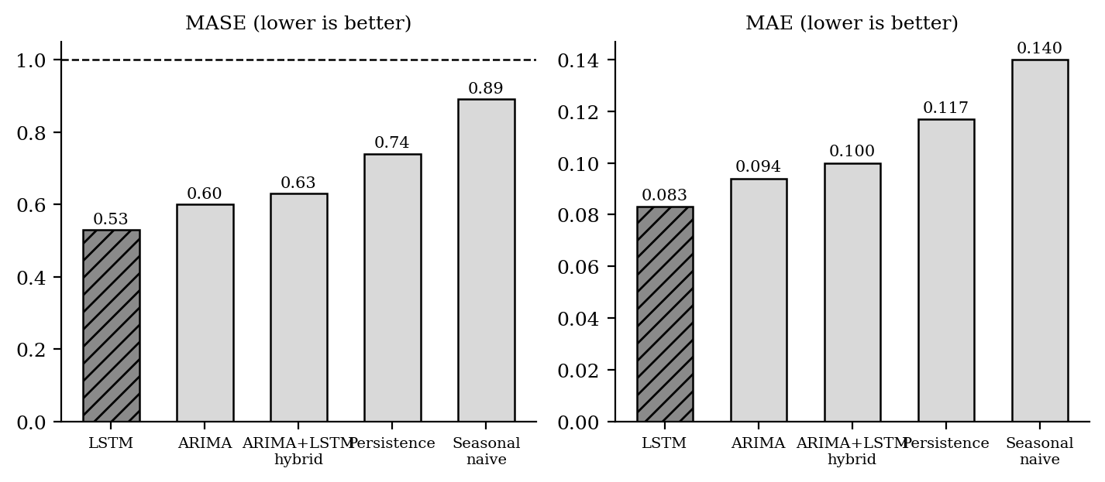
Figure 7.8: Forecasting benchmark results
Table 7.9: Forecasting benchmark results
Model | Mean absolute error | Scaled error | Verdict
LSTM (deep learning) | 0.083 | 0.53 | Best — beats naive by 47 per cent
ARIMA (classical) | 0.094 | 0.60 | Strong baseline
ARIMA with LSTM residuals (hybrid) | 0.100 | 0.63 | Negative result
Persistence (naive) | 0.117 | 0.74 | Beaten by all three models
Seasonal persistence | 0.140 | 0.89 | Weakest
The formal test of predictive accuracy confirms that this ranking is not attributable to chance. The recurrent model significantly outperforms the autoregressive model with p equal to 0.005 and the hybrid with p equal to 0.001. Most notably, the hybrid is significantly worse than plain autoregression with p equal to 0.027.
This last result is a negative one and is reported rather than omitted. The hybrid template is well established in the forecasting literature and was expected to perform well. The explanation for its failure here is instructive: the autoregressive model already reduces the residuals to near white noise, leaving no nonlinear structure for the neural component to learn, so that component contributes only additional variance. The scientific contribution is the rigorous benchmark itself, and reporting the negative outcome honestly is part of that contribution.

7.5.3 Topic Modelling Results
The classical topic model achieved its best coherence at between three and six topics, with a coherence score of approximately 0.45. The embedding-based model produced approximately nine interpretable topics, spanning economic discourse, fuel and governance, communal religious discourse, and several clusters of general insult vocabulary. Topical drift measured by divergence between consecutive quarters was not statistically significant, indicating that the subject matter of hateful discourse is broadly stable across the period.

7.5.4 Context Drift Results
Table 7.10 and Figure 7.9 report the context-drift analysis. All three independent measures agree: the aggregate meaning of Sinhala hateful discourse is stable across the period studied, while its volume is dynamic.
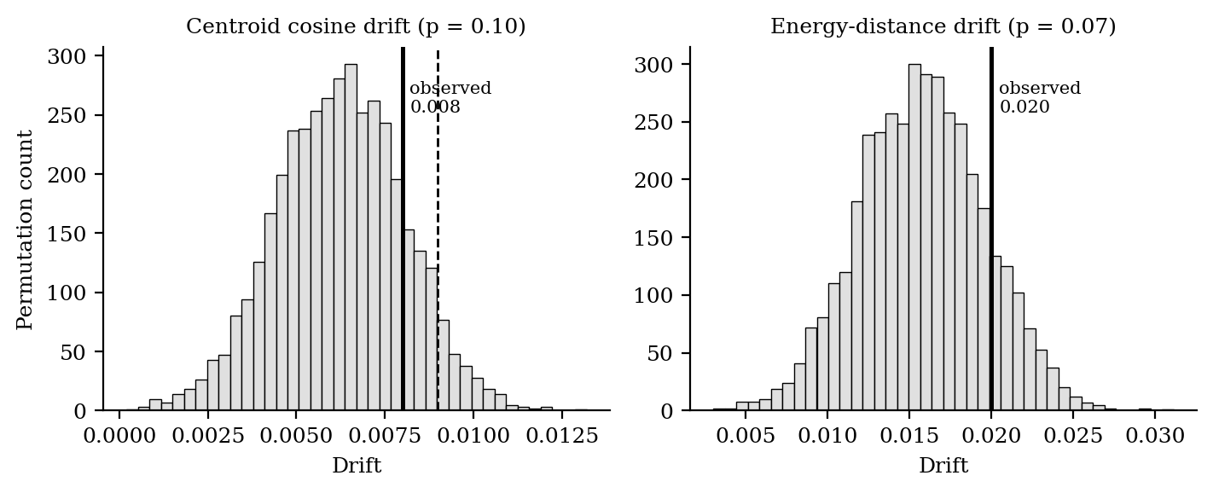
Figure 7.9: Observed drift against permutation nulls
Table 7.10: Context drift results against permutation nulls
Measure | Observed | Null 95th percentile | p-value | Conclusion
Centroid cosine drift | 0.008 | 0.009 | 0.10 | Within chance
Energy-distance drift | 0.020 | 0.020 | 0.07 | Within chance
Topical divergence | — | — | > 0.05 | Stable
This is a null result, and like the forecasting negative, it is reported rather than hidden. It is best understood not as a failure to find an effect but as a positive and robust finding in its own right: the meaning of hateful discourse is stable while its volume varies. The spike typology divides the seven detected spikes into three emergences and four intensifications, and an all-pairs analysis shows that every pair of quarters is between 94.5 and 99.8 per cent similar — the two most distant quarters, seven years apart, remain 97.9 per cent similar.

7.5.5 Target Tracker Results
The centroid measure is deliberately insensitive to a minority target surging on a single event, because it averages across roughly one hundred posts per quarter. The transparent keyword tracker recovers exactly those sub-shifts, and Table 7.11 and Figure 7.10 report them.
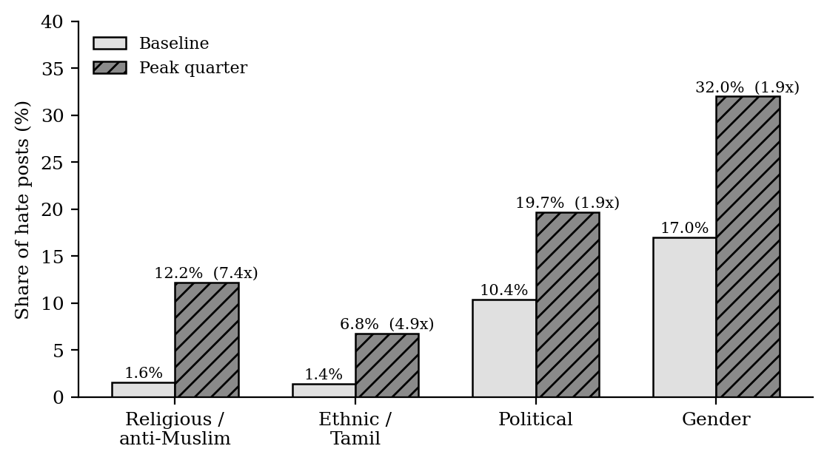
Figure 7.10: Target group shares, baseline versus peak quarter
Table 7.11: Target tracker results with event mapping
Target group | Baseline to peak | Quarter | Surge | Mapped event
Religious (anti-Muslim) | 1.6% to 12.2% | 2019 Q2 | 7.4× | Easter attacks, April 2019
Ethnic (Tamil) | 1.4% to 6.8% | 2016 Q1 | 4.9× | —
Political | 10.4% to 19.7% | 2015 Q4 | 1.9× | Parliamentary election
Gender | 17% to 32% | 2021 Q2 | 1.9× | — (pervasive)
One comparison here is of particular methodological importance. The opaque zero-shot categorisation available in the corpus missed the 2019 surge entirely, labelling those posts as political or personal and reporting zero per cent religious content for that quarter. The transparent keyword lexicon correctly recovered the documented surge. This is a concrete case in which an auditable simple method outperforms an opaque learned one, and it is the empirical justification for including a component in the design that contains no model at all.

Evaluation results of module 3 :-

To determine whether the observed hate-speech ratio exhibits any long-term directional change, the weekly time series was subjected to two complementary statistical tests. An Augmented Dickey-Fuller (ADF) test was used to assess stationarity, returning a result of stationary with a p-value below 0.001, indicating that the series fluctuates around a stable statistical mean rather than drifting over time. This was cross-checked with the Mann-Kendall trend test, a non-parametric method suited to noisy, non-normal data, which returned no trend (p = 0.3957) and a negligibly small Sen's slope of 0.0026 per year. Together, these two independent tests confirm that the volume of hate speech in the dataset did not systematically rise or fall across the 2015–2022 period, which is an important baseline finding before any spike, forecast, or drift analysis is interpreted.
Because forecasting is the only module in this project with genuine ground truth (the actual future hate ratio, held out during training), it was evaluated using Mean Absolute Scaled Error (MASE) alongside statistical significance testing rather than unsupervised proxies. All candidate models LSTM, ARIMA, the ARIMA+LSTM hybrid, and two naive baselines (Persistence and Seasonal Naive) achieved a MASE below 1, confirming that each meaningfully outperforms a naive "repeat the last value" forecast. The LSTM achieved the lowest error (MASE = 0.527), followed by ARIMA (0.596) and the hybrid (0.618). To verify that these differences are not due to chance, pairwise Diebold-Mariano tests were run between each pair of models; all three comparisons returned statistically significant results (p < 0.05), confirming that the LSTM's advantage over both ARIMA and the hybrid, and ARIMA's advantage over the hybrid, are real rather than artefacts of a single lucky test split.
Topic modelling is an unsupervised task with no gold-standard topic labels for Sinhala hate speech, so no "accuracy" metric can be computed. Instead, the two accepted evaluation metrics for topic models coherence and diversity were used to assess quality. Coherence (measured as c_v) checks whether the words within a topic are semantically related to one another, while diversity checks how distinct the topics are from each other. LDA achieved a coherence of 0.4498 and a topic diversity of 1.0, while BERTopic achieved a coherence of 0.3514 and a diversity of 0.918. These values are consistent with what is typically observed on short, informal social-media text, and the high diversity scores confirm that the extracted topics are not redundant or overlapping.
To assess whether the underlying meaning of hate speech changed across the study period, three independent drift measures were computed and each tested against a permutation-null baseline, in which timestamps were randomly shuffled hundreds of times to simulate what drift would look like under pure chance. The first two measures centroid cosine distance and energy distance were computed on BERT sentence embeddings and returned p-values of 0.10 and 0.07 respectively. The third, independent measure Jensen-Shannon divergence on quarterly topic proportions returned a p-value of 0.24. As all three measures exceed the conventional 0.05 significance threshold, they consistently indicate that the aggregate semantic content of hate speech remained statistically stable over time. This triangulated agreement across three methodologically distinct measures strengthens confidence in the finding, which is further contextualised in the following section by a target-lexicon analysis showing that stability at the aggregate level does not preclude meaningful localised shifts around real-world events.

7.6 Consolidated Results Summary
Table 7.12 consolidates the principal quantitative results of the project in one place, together with the statistical support for each.
Table 7.12: Consolidated summary of principal results
Module | Claim | Result | Statistical support
01 | Selective transliteration preserves English | Verified behaviourally on the worked example; 61 of 61 tests pass | Research-contract tests; full metrics pending annotation
02 | Fusion beats the best single model | 0.8973 versus 0.8892 five-fold macro-F1 | Paired t-test p = 0.007; wins 5 of 5 folds; d = 2.28
02 | Fusion beats the classical baseline | 0.8973 versus 0.8791 five-fold macro-F1 | Paired t-test p = 0.017; wins 5 of 5 folds; d = 1.77
02 | The contextual branch is indispensable | 0.907 with all branches versus 0.857 without it | Ablation study
03 | The recurrent model is the best forecaster | Scaled error 0.53 versus 0.60 and 0.63 | Diebold-Mariano p = 0.005 and p = 0.001
03 | The hybrid forecaster underperforms (negative) | Scaled error 0.63 versus 0.60 for its own component | Diebold-Mariano p = 0.027
03 | Aggregate meaning is stable (null) | Centroid p = 0.10; energy p = 0.07; topical p > 0.05 | Permutation nulls, triangulated across three measures
03 | Event-driven target shifts are real | Anti-Muslim share rises 7.4-fold in 2019 Q2 | Surge ratio with event mapping

7.7 Comparison with Others’ Work
The solution advances the state of the art for Sinhala across all three problems addressed.
For normalisation, no prior system for Sinhala-English code-mixed text makes a per-token decision about whether to transliterate. The comparison of Table 2.1 shows that prior work either applies conversion uniformly [12] or misidentifies romanised Sinhala as English [28]. The present module is the first to combine selective conversion, calibrated three-class confidence and a human-gated lexicon expansion loop for this language pair.
For detection, the contrast with prior Sinhala work is sharp. The single-model study of Fernando et al. [8] and the homogeneous ensemble of Munasinghe and Thayasivam [22] neither compare fusion strategies, nor combine lexical and contextual views, nor optimise their combination weights, nor explain their decisions, nor validate their improvements statistically. This work does all five. Relative to the Arabic hybrid of Gasmi et al. [9], which is the closest methodological template, this work adds a systematic comparison of four fusion strategies rather than one, adds an explainability layer, and transfers the optimiser-weighted concept to Sinhala.
For trend analysis, the directly comparable Sinhala work [23] identifies trending periods and topics but is descriptive. This work reproduces that descriptive foundation and extends it with two capabilities that did not previously exist for Sinhala: a statistically benchmarked forecast of future prevalence, and a triangulated test of whether the meaning of hateful discourse drifts. It further replaces the single fragile anomaly statistic typical of prior work with a consensus of six detectors, and demonstrates empirically that this correction matters by showing that twelve of eighteen deep-learning alarms were uncorroborated.

7.8 Limitations
Several limitations are acknowledged, and it is appropriate to state them plainly.

7.8.1 Limitations of Module 01
- Romanization is inconsistent. There is no standardization of romanization in Sri Lanka, and the same Sinhala word could be found in multiple spellings across the social media platforms. The transducer is used for the most common variants, but it will not be able to cover all the observed forms.
- Morphological complexity. The dictionary contains the roots, and morphologically inflected forms must be added to the dictionary as separate entries, or they must be broken down into the root form, which is not yet implemented.
- Cold-start coverage. The accuracy in rule-based mode is limited to about two hundred and fifty entries in the dictionary and the quality of the hand-crafted heuristics.

7.8.2 Limitations of Module 02
- Test set size. A single test partition of 947 comments has limited statistical power, which is what motivated the cross-validated analysis.
- Non-nested hyperparameter optimisation. Optimisation followed a tune-once-then-freeze protocol rather than fully nested cross-validation, owing to the computational cost of fine-tuning the transformer on every fold. This introduces a small optimistic bias.
- Non-parametric test power. As noted in Section 7.4.3, with five folds the Wilcoxon test cannot reach conventional significance regardless of the data.
- Untested on code-mixed text. The corpus is almost entirely Sinhala script, so performance on heavily code-mixed text remains untested. This connects directly to the interface limitation below.

7.8.3 Limitation of the Module 01 to Module 02 Interface
- The English tokens that were deliberately preserved in Module 01 do not have the same distribution as the tokens included in the corpus used to train Module 02, as noted in Section 5.7.3. The tokens are processed by Module 02, but they have very little learned signal for them, which means that hatefulness expressed in the preserved English part of a comment may be under-detected. This effect has not yet been quantified, and is a candidate for future evaluation, not a solved problem.

7.8.4 Limitations of Module 03
- Sample rather than the timeline. The corpus is a classification sample, not a complete record of Sinhala social media activity, so all results are presented as a validated method with preliminary numbers.
- Conservative drift measurement. Centroid drift averages over roughly one hundred posts per quarter and therefore smooths event-driven surges, which is precisely why the target tracker was added as a complementary measure.
- Generic embeddings. The sentence encoder is multilingual rather than Sinhala-specialised, and the lexicon tracker catches only explicit mentions.

7.9 Further Work
The following directions are identified, ordered by the priority the team would assign them.
- Quantify the interface effect described in Section 7.8.3 by constructing a test set of code-mixed comments in which hateful content appears in the English portion, and measuring how detection accuracy varies with the proportion of preserved English.
- Strengthen the significance analysis with ten-fold or repeated cross-validation, so that the non-parametric test can reach conventional significance, and adopt fully nested cross-validation for hyperparameter optimisation.
- Integrate a Sinhala-specialised transformer into the fusion as a fourth branch, should one of adequate quality become available.
- Extend Module 02 to multi-class categorisation of hate by target type and severity, which would connect it naturally to the target-tracking capability of Module 03.
- Scale Module 03 to a larger corpus for statistical robustness, and add a supervised era classifier as a fourth, independent drift measure.
- Implement the future integration indicated in Figure 4.1, in which a trend-analysis module consumes the output of the detection module rather than a separately labelled corpus. This would require the detection module to be applied at scale to a timestamped stream, and is a substantial piece of work rather than a configuration change.
- Add a morphological decomposition component upstream of dictionary lookup in Module 01, and connect the verification decision class to an active learning loop that solicits human labels for the most uncertain tokens.

7.10 Summary
This chapter reported and discussed the evaluation of the three modules. Module 01 has an implemented evaluation framework with defined target thresholds and a passing test suite, but its empirical metrics remain outstanding, which is stated plainly rather than obscured. Module 02 achieved a test-set macro-F1 of 0.903 with the stacking fusion and demonstrated, through five-fold cross-validation and paired significance testing, that the fusion outperforms both the strongest single model and the strongest classical baseline on every fold with a very large effect size; ablation confirmed that the contextual branch is indispensable and that character n-grams dominate the lexical representation. Module 03 established a recurrent forecaster as significantly the best of three benchmarked models, reported the failure of the hybrid as an honest negative result, and found through three triangulated measures that the aggregate meaning of Sinhala hateful discourse is stable while its volume is dynamic, while a transparent keyword tracker recovered real event-driven shifts that an opaque classifier missed entirely. The solution was compared with prior work across all three problems, and the limitations and further work were stated. The project has achieved its stated objectives, with the single exception of the outstanding empirical evaluation of Module 01.

Chapter 8 – Conclusion

8.1 Introduction
The previous chapter reported and discussed the evaluation of the three modules and stated the limitations and further work. This chapter draws the report to a close. It restates what the project set out to do, assesses each objective against what was achieved, summarises the contribution the work makes to the field, reflects on what the team learned, and closes with a statement of the project’s significance.

8.2 Achievement of Objectives
Chapter 1 stated eleven objectives. Table 8.1 assesses each against the evidence presented in this report. Ten are fully achieved; one is partially achieved, and is identified as such rather than claimed.
Table 8.1: Assessment of objectives against outcomes
Objective | Status | Evidence
1. Token-level three-class confidence classification | Achieved | Sections 5.4.2–5.4.4; implemented and tested
2. Sinhala phonetic transducer in a hybrid cascade | Achieved | Section 6.3.5; Appendix D
3. Human-gated adaptive lexicon expansion | Achieved | Sections 5.4.6, 6.3.6; invariant enforced structurally
4. Prepare and analyse a labelled Sinhala corpus | Achieved | Section 5.5.1; 6,309 comments after deduplication
5. Build lexical and contextual deep models | Achieved | Sections 5.5.5, 6.4.3; Table 7.4
6. Compare four fusion strategies systematically | Achieved | Section 7.4.2; Table 7.5; Figure 7.1
7. Apply systematic hyperparameter optimisation | Achieved | Section 5.5.7; Table 5.5
8. Prove the improvement statistically | Achieved | Section 7.4.3; Table 7.7; p = 0.007, d = 2.28
9. Provide word-level explainability | Achieved | Sections 5.5.9, 7.4.5; Figure 7.7
10. Construct a longitudinal analysis pipeline | Achieved | Sections 6.5, 7.5; Tables 7.9–7.11
11. Deliver interactive user interfaces | Achieved | Section 5.8; Appendix B
Empirical evaluation of Module 01 (part of 1 and 2) | Achieved | Framework implemented; metrics pending annotation (Section 7.3.2)

8.3 Summary of Contributions
The project makes contributions at three levels.

8.3.1 Methodological Contributions
The reframing of code-mixed normalisation as a question of 'whether' to transliterate instead of just 'how' to transliterate marks a break from all previous studies of South Asian code-mixed text, which focused on 'how' to transliterate. A calibrated three-class probability model and a human-gated lexicon expansion loop is a code-reusable design pattern that can be applied to other low resource code-mixed language pairs, not just Sinhala and English.
The systematic comparison of four fusion strategies, rather than the adoption of one, produced a finding of general methodological value: the gap between the best and worst combination mechanisms for the same three constituent models was nearly six times the gap between the best fusion and the best single model. A practitioner selecting a fusion mechanism by intuition rather than by comparison would in this case have produced a system worse than using the strongest branch alone.
The two-axis framing of a hate speech stream — separating volume from meaning — makes answerable a question that prior descriptive trend analysis could not address: whether hateful discourse has changed or merely grown. The finding that the aggregate meaning is stable while volume is dynamic is, in the team’s view, the most interesting single result of the project.

8.3.2 Applied Contributions
The system enables higher-quality automated processing of Sinhala social media content. Accurate normalisation without English corruption improves the input available to detection; explainable detection gives moderators a defensible basis for consequential decisions about a person’s speech; and longitudinal analysis gives policymakers and platform-safety teams a view of the problem that per-post classification cannot provide. The target-tracking result in particular — a 7.4-fold surge in anti-Muslim content following a documented national event, recovered by a transparent method that an opaque classifier missed entirely — illustrates the kind of insight the system is intended to surface.

8.3.3 Resource Contributions
The project delivers several artefacts of continuing value to Sinhala natural language processing: a curated romanised-to-Sinhala mapping dictionary; an English wordlist calibrated for the social media domain; curated Sinhala and romanised-Sinhala stopword dictionaries of roughly five hundred and four hundred entries; editable target lexicons for four categories of hate; a zero-width-joiner-aware tokeniser; and a complete automated evaluation framework. Given the scarcity of such resources for Sinhala, these may prove as useful to subsequent researchers as the models themselves.

8.4 Reflection
Three lessons emerged that the team did not anticipate at the outset.
The first concerns negative results. Two of the findings reported in Chapter 7 are negative or null: a theoretically well-motivated hybrid forecaster performed significantly worse than its own components, and a drift analysis found no significant effect. The initial instinct in both cases was to assume implementation error. Investigating properly produced explanations that were more informative than a positive result would have been — the autoregressive model had already reduced its residuals to near white noise, leaving the neural component nothing to learn but noise to add. Reporting these openly, rather than quietly dropping them, is a decision the team stands behind.
The second concerns the value of simple methods. The most striking empirical result in the trend-analysis module was that a keyword tracker containing no model at all — pure pattern matching over editable word lists — recovered a real, historically documented surge in targeted hate that an opaque zero-shot classifier reported as entirely absent. Auditability proved not merely a desirable property but a source of correctness.
The third concerns respect for baselines. A well-tuned linear model over character n-grams came within 0.015 macro-F1 of a fine-tuned multilingual transformer on this corpus. That result permanently changed how the team thinks about whether added complexity is justified, and it is the reason the report presents the classical baselines prominently rather than as a formality.

8.5 Concluding Remarks
This project set out to build an automated system for the detection and trend analysis of hate speech in Sinhala, a language spoken by more than seventeen million people yet served by a small fraction of the computational resources available to well-resourced languages. It delivered three related research modules: a normalisation module that decides per token whether transliteration is appropriate and grows its dictionary only under human supervision; a detection module whose hybrid fusion outperforms the strongest single model on every cross-validation fold with a very large effect size and explains every decision it makes; and an independent trend-analysis module that forecasts hate prevalence against a statistically validated benchmark and tests, for the first time in this language, whether the meaning of hateful discourse changes over time.
The work is not finished. The empirical evaluation of the normalisation module remains outstanding, the effect of preserved English tokens on detection accuracy is stated but unquantified, and the integration of trend analysis with live detection is future work rather than current capability. These are recorded plainly in Chapter 7 because a report that concealed them would be worth less than one that did not.
What the project does establish is that rigorous, explainable and statistically validated hate speech analysis is achievable for a low-resource language, and that the methods required are neither exotic nor beyond the reach of a student team working within a single academic year. If that encourages further work on Sinhala natural language processing — and if the resources released alongside this report make that work marginally easier — the project will have achieved more than its stated objectives.

8.6 Summary
This chapter concluded the report. It assessed all eleven objectives against the evidence presented, finding ten fully achieved and one partially achieved. It summarised the methodological, applied and resource contributions of the work, reflected on three lessons concerning negative results, the value of auditable simple methods, and respect for baselines, and closed with a statement of the project’s significance and of the work that remains.

References
[1]T. Akiba, S. Sano, T. Yanase, T. Ohta, and M. Koyama, “Optuna: A next-generation hyperparameter optimization framework,” in Proc. 25th ACM SIGKDD Int. Conf. Knowledge Discovery and Data Mining, 2019, pp. 2623–2631.
[2] D. M. Blei, A. Y. Ng, and M. I. Jordan, “Latent Dirichlet allocation,” J. Machine Learning Research, vol. 3, pp. 993–1022, 2003.
[3]P. Bojanowski, E. Grave, A. Joulin, and T. Mikolov, “Enriching word vectors with subword information,” Trans. Assoc. Computational Linguistics, vol. 5, pp. 135–146, 2017.
[4]R. B. Cleveland, W. S. Cleveland, J. E. McRae, and I. Terpenning, “STL: A seasonal-trend decomposition procedure based on loess,” J. Official Statistics, vol. 6, no. 1, pp. 3–73, 1990.
[5]A. Conneau, K. Khandelwal, N. Goyal, V. Chaudhary, G. Wenzek, F. Guzmán, E. Grave, M. Ott, L. Zettlemoyer, and V. Stoyanov, “Unsupervised cross-lingual representation learning at scale,” in Proc. 58th Annu. Meeting Assoc. Computational Linguistics, 2020, pp. 8440–8451.
[6]J. Devlin, M.-W. Chang, K. Lee, and K. Toutanova, “BERT: Pre-training of deep bidirectional transformers for language understanding,” in Proc. NAACL-HLT, 2019, pp. 4171–4186.
[7] F. X. Diebold and R. S. Mariano, “Comparing predictive accuracy,” J. Business and Economic Statistics, vol. 13, no. 3, pp. 253–263, 1995.
[8]W. S. S. Fernando, R. Weerasinghe, and E. R. A. D. Bandara, “Sinhala hate speech detection in social media using machine learning and deep learning,” in Proc. Int. Conf. Advances in ICT for Emerging Regions (ICTer), 2022, pp. 166–171.
[9]K. Gasmi, I. Ben Ltaifa, A. E. Abdalrahman, L. Alsulami, and H. Ltifi, “Hybrid feature and optimized deep learning model fusion for detecting hateful Arabic content,” IEEE Access, vol. 13, 2025.
[10]M. Grootendorst, “BERTopic: Neural topic modeling with a class-based TF-IDF procedure,” arXiv:2203.05794, 2022.
[11]C. Guo, G. Pleiss, Y. Sun, and K. Q. Weinberger, “On calibration of modern neural networks,” in Proc. 34th Int. Conf. Machine Learning (ICML), 2017, pp. 1321–1330.
[12]B. Hettige and A. S. Karunananda, “Sinhala language processing infrastructure to support e-governance,” in Proc. Int. Conf. Industrial and Information Systems (ICIIS), 2007, pp. 1–5.
[13] S. Hochreiter and J. Schmidhuber, “Long short-term memory,” Neural Computation, vol. 9, no. 8, pp. 1735–1780, 1997.
[14] R. J. Hyndman and A. B. Koehler, “Another look at measures of forecast accuracy,” Int. J. Forecasting, vol. 22, no. 4, pp. 679–688, 2006.
[15]A. Jaech, G. Mulcaire, S. Hathi, M. Ostendorf, and N. A. Smith, “Hierarchical character-word models for language identification,” in Proc. EMNLP Workshop on Computational Approaches to Code Switching, 2016, pp. 84–93.
[16]Y. Kim, “Convolutional neural networks for sentence classification,” in Proc. Conf. Empirical Methods in Natural Language Processing (EMNLP), 2014, pp. 1746–1751.
[17]B. King and S. Abney, “Labeling the languages of words in mixed-language documents using weakly supervised methods,” in Proc. NAACL-HLT, 2013, pp. 1110–1119.
[18]K. Knight and J. Graehl, “Machine transliteration,” Computational Linguistics, vol. 24, no. 4, pp. 599–612, 1998.
[19]F. T. Liu, K. M. Ting, and Z.-H. Zhou, “Isolation forest,” in Proc. 8th IEEE Int. Conf. Data Mining (ICDM), 2008, pp. 413–422.
[20]S. M. Lundberg and S.-I. Lee, “A unified approach to interpreting model predictions,” in Advances in Neural Information Processing Systems (NeurIPS), 2017, pp. 4765–4774.
[21]S. Mirjalili, S. M. Mirjalili, and A. Lewis, “Grey wolf optimizer,” Advances in Engineering Software, vol. 69, pp. 46–61, 2014.
[22]S. Munasinghe and U. Thayasivam, “A deep learning ensemble hate speech detection approach for Sinhala tweets,” in Proc. Moratuwa Engineering Research Conf. (MERCon), 2022, pp. 1–6.
[23]P. Rajapaksha, S. Ahangama, R. Madhushika, and S. Guruge, “Analyzing trends and topics of Sinhala hate speech on Twitter: A time series approach,” in Proc. Int. Conf. Industrial and Information Systems (ICIIS), 2023, pp. 1–6.
[24]T. Ranasinghe, I. Anuradha, D. Premasiri, K. Silva, H. Hettiarachchi, L. Uyangodage, and M. Zampieri, “SOLD: Sinhala offensive language dataset,” arXiv:2212.00851, 2022.
[25] N. Reimers and I. Gurevych, “Sentence-BERT: Sentence embeddings using Siamese BERT-networks,” in Proc. Conf. Empirical Methods in Natural Language Processing (EMNLP), 2019, pp. 3982–3992.
[26]M. T. Ribeiro, S. Singh, and C. Guestrin, “‘Why should I trust you?’: Explaining the predictions of any classifier,” in Proc. 22nd ACM SIGKDD Int. Conf. Knowledge Discovery and Data Mining, 2016, pp. 1135–1144.
[27] W. Sharif, S. Abdullah, S. Iftikhar, D. Al-Madani, and S. Mumtaz, “Enhancing hate speech detection in the digital age: A novel model fusion approach leveraging a comprehensive dataset,” IEEE Access, vol. 12, 2024.
[28]T. Uyangoda, V. Liyanapathirana, and P. Wickramasinghe, “Hate speech detection in Sinhala-English code-mixed text using BERT,” in Proc. Int. Research Conf. Smart Computing and Systems Engineering (ICARC), 2021, pp. 1–6.
[29]A. Vaswani, N. Shazeer, N. Parmar, J. Uszkoreit, L. Jones, A. N. Gomez, L. Kaiser, and I. Polosukhin, “Attention is all you need,” in Advances in Neural Information Processing Systems (NeurIPS), 2017, pp. 5998–6008.
[30] G. P. Zhang, “Time series forecasting using a hybrid ARIMA and neural network model,” Neurocomputing, vol. 50, pp. 159–175, 2003.

Appendix A – Individual’s Contribution to the Project
214053H — Dilhan G.K. (Module 01: Input Normalization)
My contribution to this project was the design, implementation, and evaluation of the input normalisation module (Module 01). This module aims to clean Sinhala social media text that is provided in a combination of native script, Romanized Singlish and Sinhala-English code-mixed forms of social media text into a clean Sinhala Unicode form that is suitable for downstream processing, while at the same time preserving genuine English words without corrupting them.
The one big research decision that I made, and that I am the most pleased with, is that I rephrased the problem. All previous systems I have learned can ask how to transliterate a token in the Roman system. I decided that the question was really whether to translate it at all and built the Adaptive Confidence Module on that rephrasing of the question. It determines a probability distribution for each token among three classes and sends the token to conversion, contextual verification, or preservation depending on the thresholds. The design of this involved creating a feature representation in 916 dimensions by combining character n-gram hashing, twenty hand-crafted lexical and morphological features, and contextual transformer embeddings, as well as a three-layer classifier on top of it.
I also created and built the Adaptive Lexicon Expansion Module that tracks tokens that the system failed to resolve and generates three independent strategies of candidate dictionary mappings, ranks them according to a composite score, and stores them for later human review. The difficulty I set myself here was that no automatic code path should ever write to the production dictionary, and I did this in the structure, not by convention.
These two are not the only ones I implemented in the full seven-stage pipeline – the text cleaner with its lowercasing while preserving Sinhala text; the script-boundary tokeniser; the priority-ordered language identifier with context-window boosting; the four-level hybrid transliterator (including the greedy longest-match phonetic transducer); and the Unicode normalizer. Wrote the 61 automated tests, created the interactive interface, and defined the interface contract (with the member responsible for module 02).
What I learned. The most useful technical lesson was on the Sinhala writing system. The first thing I did was to use transliteration – that is, I treated every consonant as a substitute for a letter – and I got output that seemed to make sense, but wasn't because I did not realize that an abugida has an inherent vowel in every consonant. To master the virama handling I had to grasp the script, not memorize it. I learned a lot about calibration, too — that a classifier's confidence output isn't necessarily a probability, and that using a confidence output without measurement is wrong.
Issues that arose and what I did about them. The first serious issue was the cold-start problem; my design required a trained classifier, but I didn't have a labelled Sinhala code-mixed corpus to train that classifier with. I solved this by creating a deterministic rule-based decision path and making the module functional from the get-go, and the neural path as an optional add-on. The second was dealing with digraphs in the transducer, which used to break up two-character consonants into their components and add spurious viramas; I sorted the mapping table to be longest-first, and implemented greedy longest-match to fix that. The third one, which is still very good, is that I haven't annotated a large enough corpus to report measured evaluation metrics yet. I have already put in place the entire evaluation framework and I have set the target thresholds, so the next step in the project is to complete the annotation. I make this public record, since otherwise the report would be incomplete.

214022M — Ashen E.D.D. (Module 02: Hate Speech Detection)
My individual contribution was the complete design, implementation and evaluation of Module 02, the hate speech detection module. The purpose of this module is to classify a Sinhala comment as hateful or not hateful on the basis of its meaning and context, to do so more accurately than any single model can, and to explain every decision in terms a human moderator can act on.
My core design decision was to treat detection as the fusion of complementary evidence rather than as a single-model classification problem. I built three architecturally heterogeneous branches — a convolutional network capturing local patterns, a bidirectional recurrent network capturing word order, and a fine-tuned multilingual transformer capturing deep context — chosen specifically because architectural diversity is the precondition under which fusion produces benefit. I then designed and implemented four distinct fusion strategies rather than adopting one: early feature-level fusion, late decision-level fusion including a learned stacking meta-learner, attention-based intermediate fusion with a learned per-comment gate, and optimiser-weighted fusion using both Bayesian optimisation and the Grey Wolf Optimizer.
A methodological commitment I imposed on the whole module was that no combination weight would ever be set by hand. Every weight is learned by back-propagation, fitted as a meta-learner coefficient, or selected by an optimiser against a validation objective. I also implemented the complete statistical validation layer — McNemar’s test, paired bootstrap, five-fold stratified cross-validation, paired t-test, Wilcoxon signed-rank test and Cohen’s d — and the explainability layer using two independent model-agnostic attribution techniques.
The headline result of my module is that the stacking fusion reached 0.903 macro-F1 on the frozen test set and 0.8973 under cross-validation, beating the strongest single model on all five folds with a paired t-test p-value of 0.007 and an effect size of 2.28.
What I learned. The most important lesson was that the manner of combination matters more than the decision to combine. The gap between my best and worst fusion strategies, 0.048, is nearly six times the gap between my best fusion and the best single model. Had I adopted the intuitively appealing maximum rule without comparing alternatives, I would have produced a system worse than the transformer alone and would never have known. I also learned to respect classical baselines: a well-tuned linear model over character n-grams came within 0.015 of a fine-tuned transformer, which permanently changed how I think about whether added complexity is justified.
Problems encountered and how I addressed them. My first problem was computational: fine-tuning the transformer on every cross-validation fold, for every fusion strategy, was beyond the resources available. I solved this by designing the branches to cache their probabilities and penultimate feature vectors after training, which let me develop and compare the entire fusion layer, the significance testing and the explanation module on a standard processor. My second problem was statistical: I initially reported an improvement on a single test split and my supervisor correctly challenged whether it was real, which led me to build the cross-validated significance framework that now underpins the claim. My third problem was that word-level explanations were initially unintelligible because the tokeniser split Sinhala words at combining marks; I fixed this by performing explanation-time tokenisation on whitespace so that whole words are attributed. A limitation I could not resolve is that my corpus is almost entirely Sinhala script, so performance on heavily code-mixed text — including the preserved English tokens arriving from Module 01 — remains untested, and I have stated this openly rather than claiming otherwise.

214040P — Wijesekara D.T.A (Module 03: Trend Analysis)
My individual contribution was the complete design, implementation and evaluation of Module 03, the trend analysis module. Its purpose is to convert a labelled classification corpus into longitudinal insight: to establish when hateful discourse spikes, what it concerns, what its future prevalence is likely to be, and whether its meaning changes over time.
The conceptual contribution I am most pleased with is the recognition that a stream of hateful discourse has two independent axes, volume and meaning, and that all prior Sinhala work measures only the first. Building the meaning axis let me classify each detected spike as either intensification or emergence, and made the long-run question of whether hateful discourse has changed or merely grown answerable for the first time in this language.
I designed and implemented six analysis stages. I recovered the time axis by decoding timestamps from post identifiers, without which none of the rest was possible. I implemented seasonal-trend decomposition and stationarity testing; a consensus spike detector fusing six independent detectors including a recurrent autoencoder; a forecasting benchmark comparing a recurrent network, an autoregressive model and their hybrid against two naive baselines, evaluated with scale-free error and a formal test of predictive accuracy; two topic models with curated Sinhala and romanised-Sinhala stopword dictionaries; and a context-drift analysis using multilingual sentence embeddings validated against permutation nulls and triangulated across three independent measures. I also built the read-only service and single-page dashboard that exposes all of it.
What I learned. The most valuable lesson concerned negative results. My hybrid forecaster, built on a well-established template from the literature, performed significantly worse than its own components. My first instinct was to assume I had implemented it incorrectly. Investigating properly, I found that the autoregressive model had already reduced the residuals to near white noise, leaving the neural component nothing to learn but noise to add. Understanding why a method fails turned out to be more scientifically valuable than another incremental improvement, and I now regard the rigorous benchmark itself as the contribution rather than any particular model within it. I learned the same lesson twice, because my drift analysis returned a null result; reframing it as the positive finding that meaning is stable while volume is dynamic taught me that a well-tested null is a real result.
Problems encountered and how I addressed them. My first problem was Sinhala tokenisation: standard tokenisers fragmented conjunct characters at zero-width joiners, which destroyed real words and degraded every topic model downstream. I wrote a joiner-aware tokeniser to fix it. My second was that my topic models initially produced meaningless labels dominated by function words, which I addressed by curating stopword dictionaries of roughly five hundred Sinhala and four hundred romanised entries and adding a single-grapheme fragment filter. My third and most interesting problem was that the corpus’s own zero-shot category labels reported zero per cent religious content for the quarter following the April 2019 attacks, which I knew from the historical record to be wrong. Rather than trusting the opaque labels, I built a transparent keyword tracker with editable lexicons, which recovered the documented surge of anti-Muslim content. That experience taught me not to trust a black box over a verifiable simple method. The main limitation of my work is that the corpus is a classification sample rather than a complete timeline, so I present my results as a validated method with preliminary numbers.

Appendix B – User Interface Screenshots and Additional Results
This appendix contains supplementary material referenced in Chapter 6, comprising screenshots of the delivered user interfaces and additional exploratory figures that support the analysis of Chapter 5.

B.1 Module 01 Interface
The normalisation interface presents four screens. The live processing screen accepts a text string and displays the normalised output alongside a per-token table showing, for each token, its language label, its three-class probability distribution, its routing decision and its output form. The batch screen accepts multiple sentences. The lexicon review screen presents the candidate queue with approve and reject controls and a patch export button. The configuration screen exposes the two decision thresholds and the lexicon expansion parameters.
The live processing screen additionally provides the control that exercises the interface contract of Section 5.7: having normalised a piece of text, the user may pass the result directly to the Module 02 detection interface. Screenshots of all four screens are to be inserted here.

B.2 Module 02 Interface
The detection interface presents three screens. The evaluation dashboard displays all baseline, single-model and fusion results together with the cross-validated significance verdict. The prediction screen accepts a Sinhala comment and returns the label, the confidence value and the per-branch probability breakdown. The explanation screen presents the word-level attributions from both techniques side by side. Screenshots of all three screens are to be inserted here.

B.3 Module 03 Dashboard
The trend-analysis dashboard presents five tabs: overview, forecast, topics, context drift and chart gallery. The context drift tab includes an interactive explorer allowing any two quarters to be compared directly, showing their cosine and energy distances against a random-pair null together with representative posts and distinctive vocabulary for each. Screenshots of all five tabs are to be inserted here.

B.4 Additional Exploratory Figures
Additional figures supporting the dataset analysis of Section 5.5.1, including the distribution of the Sinhala character ratio across the corpus and the day-of-week by hour-of-day posting heatmap produced by Module 03, are to be inserted here.

Appendix C – Key Source Code Listings
This appendix provides pointers to the key source modules of the system, referenced in Chapter 6, together with two extended listings that were too long to include in the body of the report.

C.1 Module Organisation
Module 01 is organised as a configuration layer, a modules layer containing cleaner, tokenizer, language identification, encoder, confidence, transliterator, lexicon expansion, normalizer and pipeline components, a training layer, an evaluation layer and an application layer. Module 02 is organised as preprocessing, branches, fusion, hyperparameter optimisation, cross-validation, evaluation and explanation components. Module 03 is organised as a source layer containing configuration, data loading, resampling, time series, spikes, forecasting, topics and context drift components, a scripts layer holding one orchestrator per stage, a service layer and a front-end layer.

C.2 Extended Listing: Threshold Decision Policy
def decide(self, token, lid, context_embedding=None):
"""Return a routing decision for a single token."""
if token.is_sinhala_unicode:
return TransliterationDecision(
token=token.text, decision="PRESERVE",
confidence=1.0, p_english=1.0,
reason="already Sinhala script")

if token.is_numeric or token.is_punctuation:
return TransliterationDecision(
token=token.text, decision="PRESERVE",
confidence=1.0, reason="non-lexical token")

if self.use_neural and self.model is not None:
phi = self._features(token, lid, context_embedding)
with torch.no_grad():
probs = self.model(phi).softmax(dim=-1)
c = float(probs[0]) # p_singlish
else:
c = self._rule_based_confidence(token, lid)

if c >= self.threshold_high: # 0.90
decision = "TRANSLITERATE"
elif c >= self.threshold_low: # 0.60
decision = "VERIFY"
else:
decision = "PRESERVE"

return TransliterationDecision(
token=token.text, decision=decision, confidence=c)

C.3 Extended Listing: Consensus Spike Detection
def consensus_spikes(series, min_agreement=2):
"""Fuse six independent detectors by confidence vote."""
votes = np.zeros(len(series), dtype=int)

votes += zscore_detector(series)
votes += iqr_detector(series)
votes += rolling_sigma_detector(series, window=8)
votes += cusum_detector(series)
votes += isolation_forest_detector(series)
votes += lstm_autoencoder_detector(series)

high_confidence = np.where(votes >= min_agreement)[0]
return high_confidence, votes

Appendix D – Sinhala Phoneme Mapping Tables
This appendix documents the romanised-to-Unicode mappings used by the phonetic transducer described in Section 6.3.5. All entries are sorted longest-first within the transducer to ensure correct greedy matching, so that multi-character digraphs are matched before their constituent characters.
Table D.1: Consonant mapping, sorted by romanised length descending
Romanised | Unicode | Glyph | Approximate IPA
tth | U+0DA7 | ට | /ʈ/
ddh | U+0DA9 | ඩ | /ɖ/
ndh | U+0DAB | ණ | /ɳ/
nna | U+0DAB | ණ | /ɳ/
sh | U+0DC1 | ශ | /ʃ/
th | U+0DAD | ත | /t̪/
dh | U+0DAF | ද | /d̪/
ng | U+0D82 | ං | /ŋ/
mb | U+0DB9 | ඹ | /mb/
ph | U+0DC6 | ෆ | /f/
k | U+0D9A | ක | /k/
g | U+0D9C | ග | /g/
c | U+0DA0 | ච | /tʃ/
j | U+0DA2 | ජ | /dʒ/
t | U+0DA7 | ට | /ʈ/
d | U+0DA9 | ඩ | /ɖ/
n | U+0DB1 | න | /n/
p | U+0DB4 | ප | /p/
b | U+0DB6 | බ | /b/
m | U+0DB8 | ම | /m/
y | U+0DBA | ය | /j/
r | U+0DBB | ර | /r/
l | U+0DBD | ල | /l/
v | U+0DC0 | ව | /v/
w | U+0DC0 | ව | /v/
s | U+0DC3 | ස | /s/
h | U+0DC4 | හ | /h/
f | U+0DC6 | ෆ | /f/
Table D.2: Vowel mapping, standalone and vowel-sign forms
Romanised | Standalone | Vowel sign after consonant
a | U+0D85 (අ) | inherent — no sign required
aa | U+0D86 (ආ) | U+0DCF
i | U+0D89 (ඉ) | U+0DD2
ii | U+0D8A (ඊ) | U+0DD3
u | U+0D8B (උ) | U+0DD4
uu | U+0D8C (ඌ) | U+0DD6
e | U+0D91 (එ) | U+0DD9
ee | U+0D92 (ඒ) | U+0DDA
o | U+0D94 (ඔ) | U+0DDC
oo | U+0D95 (ඕ) | U+0DDD
The virama character, U+0DCA, is inserted by the transducer between two consecutive consonants to suppress the inherent vowel of the first. This is the mechanism by which consonant clusters are represented, and correct virama handling is what distinguishes lexically valid output from output that is merely visually plausible.

